**M.S.P. MANDALS**

**DEOGIRI COLLEGE, AURANGABAD**



**DEPARTMENT OF CS, IT & ANIMATION**

**Project report on**

**“Registration Co-vaccine for the Dr. Babasaheb Ambedkar Marathwada University Aurangabad."**

**SUBMITTED BY**

Sunil D. Rathod (Roll No:96)

**B.SC (Computer science), II Year**

**PROJECT GUIDE BY**

Dr. Anita G. Khandizod



* **ACKNOWLEDGEMENT**

At every outset I express my gratitude to almighty lord for showering his grace and blessing upon us to complete this seminar project. Although our name appears on the cover of this project, many people vaccinated through this project. We could not have done this case study without the assistance or support of each of each of the following. We thank all of you.

I wish to place on my deep sense of gratitude towards my project guide Dr. Anita G. khandizod mam for the constant motivation and valuable help through the project. I also want to express my gratitude towards our head of the department Dr. S.N. Helambe Sir, for his invaluable guidance, insightful advice and continue encouragement. I also extend my thanks to other facilities for their department. We also thank to those who directly as well as indirectly supported us for completion of this report.

Thanking you

* **ABSTRACT**

Vaccines contain tiny fragments of the disease-causing organism or the blueprints for making the tiny fragments. They also contain other ingredients to keep the vaccine safe and effective. These latter ingredients are included in most vaccines and have been used for decades in billions of doses of vaccine. Each vaccine component serves a specific purpose, and each ingredient is tested in the manufacturing process. All ingredients are tested for safety.

The number of severe acute respiratory syndrome coronavirus 2 (SARS-CoV-2)-infected patients keeps rising in most of the European countries despite the pandemic precaution measures. The current antiviral and anti-inflammatory therapeutic approaches are only supportive, have limited efficacy, and the prevention in reducing the transmission of SARS-CoV-2 virus is the best hope for public health. It is presumed that an effective vaccination against SARS-CoV-2 infection could mobilize the innate and adaptive immune responses and provide a protection against severe forms of coronavirus disease 2019 (COVID-19) disease. As the race for the effective and safe vaccine has begun, different strategies were introduced. To date, viral vector-based vaccines, genetic vaccines, attenuated vaccines, and protein-based vaccines are the major vaccine types tested in the clinical trials. Over 80 clinical trials have been initiated; however, only 18 vaccines have reached the clinical phase II/III or III, and 4 vaccine candidates are under consideration or have been approved for the use so far. In addition, the protective effect of the off-target vaccines, such as Bacillus Calmette-Guérin and measles vaccine, is being explored in randomized prospective clinical trials with SARS-CoV-2-infected patients. In this review, we discuss the most promising anti-COVID-19 vaccine clinical trials and different vaccination strategies in order to provide more clarity into the ongoing clinical trials.

**INDEX**

|  |  |  |
| --- | --- | --- |
| **Sr.No** | **Topic Names** | **Page No** |
| 1 | Introduction of project | 6 |
| 2 | objective | 6 |
| 3 | Scope | 6 |
| 4 | Features | 7 |
| 5 | Motivations | 7 |
| 6 | S\w and H\w requirement | 7 |
| 7 | Web structure design  E-R Diagram | 8 |
| 8 | Source code | 9 |
| 9 | Sample screen | 89 |
| 10 | Conclusion | 97 |
| 11 | references | 97 |

* **INTODUCTION**

This website is developed to Register for COVID-19 Vaccination for All Colleges whose working under the Dr. Babasaheb Ambedkar Marathwada University Aurangabad. In this project we design different forms, for designing purpose using HTML platform. These website is also helpful for know the live update on corona virus. After get vaccinated with us, we will give you UNIQUE get pass-code, you can considered it as a your Entry code for your college or university. without entry code you will be not allowed in the college.

Your Entry code will update at that time of every dose. For our confirmation If by chance you forget your entry code then you also can get it back using your registered phone number or email id to sending one SMS. here also available answer of your every frequently ask question.

* **OBJECTIVE**

The opening of educational institutions posses a great risk to students, parents, teachers, staff and the non teaching staff. That’s why we suggest you to let’s get vaccinated and come back to the college.

Now a day’s Everyone are not a comfortable with online classes because of everyone’s don’t have Smartphone, and also network issue etc.

That’s why we should get vaccinated and re-open our college’s.

Now a days because of pandemic Everyone are financially braked, that’s why we want to make everyone vaccinated in free of cost.

* **SCOPE**

Already more than four crore people have taken the vaccine and if we can consider it to be a safety trial, it has been successful. We need to increase the timings and open up for allowing vaccinations outside the hospitals too, If the vaccines are available and the identified age groups are not coming forward, it is better to invite all those interested as it is not wise to waste doses and vials or delay for those willing to take.

The information is stored in the database of BAMU. University https://bamua.digitaluniversity.ac/

* **FEATURES**

• candidate can register from anywhere, at any time in India if he/she is belongs to Bamu university.

• Candidate can make his/her account in the website.

• If in case candidate forget his/her password then he/she can get it back by using forgot password.

• Candidate can register using smartphone, laptop, or desktop.

* **MOTIVATION**

Unfortunately, this is a corner of the global vaccination. This is an online platform so you don't have to go to the crowd. Avoid the corona deaths then compulsory you take the vaccine. In this vaccination platform all of you safely vaccination, Take each dose and get rid of the corona Trials involving most of student only just beginning and are by necessity slow, given safety concerns, which means researchers work down the age ranges, and lower infection rates.

* **S\W AND H\R REQUIREMENT SPECIFICATION**
* Software requirement:

Operating system:-windows 10

Language-HTML

Browser:-Any of Mozilla, Opera, chrome etc.

Software development kit:- Sublime3 text editor

Scripting language enable:-CSS,JS.

* Hardware Requirements:

Pentium IV or higher, (PIV-300GHz recommended)

256 RAM

1GB hard Drive

* **E R DIGRAM**

**Register/Login**

1. 1

**Account**

**Candidate**

N 1

**Has**

**Study/Work**

1 M M

**Contact**

**College**

**University**

N M

**Provides**

**Vaccine**

**Take**

M M

* **SOURCE CODE**
* **HTML CODE OF HOME PAGE**

<html>

<head>

<title></title>

</head>

<link rel="stylesheet" type="text/css" href="css/index1.css">

<meta name="viewport" content="width=device-width, initial-scale=1.0">

<body>

<p style="color:white; margin-top: 1.5%; margin-bottom: 0.1%; font-size: 24px; text-align: center; background: rgba(0,0,0,0.2); ">|| Registration Co-vaccine for Dr. Babasaheb Ambedkar Marathwada University Aurangabad ||</p>

</p>

<div class="wrapper">

<ul>

<a href="index.html"><li>home</li></a>

<li>About

<ul>

<a href="html/aboutus.html"><li>About Us</li></a>

<a href="html/aboutvc.html"><li>About Vaccine </ul></li></a>

<a href="html/student.html"><li>Registration</li></a>

<a href="html/gallary.html"><li>gallary</li></a>

<a href="html/update.html"><li>update</li></a>

<a href="html/contactus2.html"><li>Contact Us</li></a>

</ul>

</div>

<h1>loading: Antibodies...</h1>

<main>

<section>

<h2 style="margin-top: 20%;">Registration now for covid-19 vaccination</h>

<p>"STAY HOME STAY SAFE" </p>

<a href="html/faq.html" class="btn2">Learn More</a>

</section>

</main>

</body>

</html>

* **CSS CODE OF HOME PAGE**

body{

background-image: url('../img/covid6.jpg');

background-size: cover;

background-repeat: no-repeat;

height: 60px;

}

*{

margin: 0; padding: 0; box-sizing: border-box;

}

header{

background-size: cover;

}

.wrapper{

width: 1500px;

margin: 0 auto;

margin-left: 13%;

}

.wrapper ul{

list-style: none;

margin-top: 3%;

}

.wrapper ul li {

background: #262626;

width: 170px;

border: 1px solid #fff;

height: 50px;

line-height: 50px;

text-align: center;

float: left;

color: #fff;

font-size: 16px;

position: relative;

font-family: poppins;

text-transform: uppercase;

font-weight: bold;

}

.wrapper ul li:hover{

background: crimson;

}

.wrapper ul ul{

display: none;

}

.wrapper ul li:hover > ul{

display: block;

}

.wrapper ul ul ul ul{

margin-left: 170px;

top: 0;

position: absolute;

}

main{

width: 100%;

display: flex;

justify-content: center;

align-items: center;

text-align: center;

color: white;

}

h1{

font-size: 45px;font-weight: 50; letter-spacing: 3px;

text-shadow: 2px 6px 8px green;

text-transform: uppercase;

margin-top: 12%;

margin-left: 5%;

text-decoration: none; color: lightyellow;

font-weight: bold;

}

section{

margin-top: none;

margin-bottom: 12%;

}

section h2 {

background: rgba(0,0,0,0.2);

margin-top: 25px;

text-transform: uppercase;

color: #eee;

word-spacing: 2px;

text-shadow: 4px 6px 10px red;

}

section p{

background: rgba(0,0,0,0.2);

font-size: 35px;

word-spacing: 4px;

margin-bottom: 35px;

margin-top: 25px;

text-shadow: 2px 2px 2px black;

color:rgba(255,204,0);

}

section a{

padding: 12px 30px;

border-radius: 4px;

outline: none;

text-transform: uppercase;

font-size: 13px;

font-weight: 500;

text-decoration: none;

letter-spacing: 1px;

}

section .btn2{

background: #262626;;

color: white;

margin-left: 10px;

background: crimson;

font-family: poppins;

text-transform: uppercase;

font-weight: bold;

}

* **HTNL CODE OF ABOUT US PAGE**

<!DOCTYPE html>

<html>

<head>

<meta name="viewport" content="width=device-width, initial-scale=1.0">

<meta name="viewport" content="width=device-width, initial-scale=1">

<style>

body {

font-family: Arial, Helvetica, sans-serif;

margin: 0;

}

html {

box-sizing: border-box;

}

*, *:before, *:after {

box-sizing: inherit;

}

.column {

float: left;

width: 33.3%;

margin-bottom: 16px;

padding: 0 8px;

}

.card {

box-shadow: 0 4px 8px 0 rgba(0, 0, 0, 0.2);

margin: 8px;

}

.about-section {

padding: 50px;

text-align: center;

background-color: #474e5d;

color: white;

}

.container {

padding: 0 16px;

}

.container::after, .row::after {

content: "";

clear: both;

display: table;

}

.title {

color: grey;

}

.button {

border: none;

outline: 0;

display: inline-block;

padding: 8px;

color: white;

background-color: #000;

text-align: center;

cursor: pointer;

width: 100%;

}

.button:hover {

background-color: #555;

}

@media screen and (max-width: 650px) {

.column {

width: 100%;

display: block;

}

}

</style>

</head>

<body>

<div class="about-section">

<h1 style="color: powderblue">ABOUT US</h1>

<p><b>Official page of bamu university registration for Co-vaccine<br><br>

This page informs you of our policies regarding the collection, use, and disclosure of personal data when you use our Service and the choices you have associated with that data.

</b></p>

</div>

<h2 style="text-align:center "><b>OUR TEAM</b></h2>

<div class="row">

<div class="column">

<div class="card">

<img src="../img/bamuimg.jpeg" alt="Jane" style="width:100%">

<div class="container">

<h2>About university</h2>

<p class="title">Chancellor: Bhagat Singh Koshyari<br>

Vice-Chancellor: Prof. Pramod Yeole</p>

<p>Dr. Babasaheb Ambedkar Marathwada University (BAMU), formerly Marathwada University, is located in Aurangabad, Maharashtra, Republic of India. It is named after Bharat Ratna "Babasaheb" Ambedkar, an Indian jurist, political leader, academic and the chief architect of the Indian Constitution.

</p>

<p><a href="http://www.bamu.ac.in/">dr.bamu.ac.in</a></p>

</p>

<p align="center"><button class="button">Contact</button>+91-0240-2403399, 2400431</p>

</div>

</div>

</div>

<div class="column">

<div class="card">

<img style="width:100%; margin-top: 15%;" src="../img/covid9.jpg" alt="Mike" >

<div class="container">

<h2>Registration for vaccine</h2>

<p class="title">Dr.BAMUA university</p>

<p>The opening of educational institutions posses a great risk to students, parents, teachers, staff and the non teaching staff. That’s why we suggest to you let’s get vaccinated and come in to the college.

</p>

<p>covid19registrationforbamu@gmail.com</p>

<p align="center"><button class="button">Contact</button>+91-xxxxxxxxx</p>

</div>

</div>

</div>

<div class="column">

<div class="card">

<img style="width:100%; margin-top: 22%;" src="../img/dr.jpg" alt="John" >

<div class="container">

<h2>Doctor</h2>

<p class="title">Healthcare service </p>

<p>Tele health consultation offers healthcare service via phone. Whoever is in need can reach out to the doctors for medical support. Communication can be through call, SMS, video call or photo.</p>

<p>co19doctor@gmail.com</p>

<p align="center"><button class="button">Contact</button>+91 025880 xxxxx</p>

</div>

</div>

</div>

</div>

<div > <a style="background-color: #4CAF50;

border: none;

color: white;

padding: 20px;

text-decoration: none;

display: inline-block;

font-size: 16px;

border-radius: 12px;

margin-left: 45%;

width: 150Px;

margin-bottom: 5%;

margin-top: 3%;

text-align: center;"

href="../index.html"><b>Home</b></a>

</div>

</body>

</html>

* **HTML CODE OF ABOUT VACCINE**

<!DOCTYPE html>

<html>

<head>

<title>about covid vaccination</title>

<meta name="viewport" content="width=device-width, initial-scale=1.0">

</head>

<body background="../img/covid3.jpg">

<br><br><br>

<h1 style="font-size: 30px;font-weight: 70; letter-spacing: 3px;

text-shadow: 2px 6px 8px green;

text-transform: uppercase;

margin-top: 6%;

margin-left: 5%;

text-decoration: none; color: red;

font-weight: bold;

background-repeat: no-repeat;

background-size: cover;

">Statement for healthcare professionals: <br>How COVID-19 vaccines are regulated for safety and effectiveness</h1>

<style type="text/css">

a:link, a:visited {

background-color: #B22222;

color: black;

border: 4px solid green;

padding: 10px 20px;

text-align: center;

text-decoration: none;

display: inline-block;

margin-left: 26%;

margin-top: 3%;

font-weight: bold;

font-family:courier,arial,helvetica;

}

a:hover, a:active {

background-color: green;

color: white;

}

</style>

<a href="https://www.mygov.in/covid-19">know more about covid vaccine</a>

</body>

</html>

* **HTML CODE OF REGISTRATION**

<!DOCTYPE html>

<html lang="en" dir="ltr">

<head>

<meta name="viewport" content="width=device-width, initial-scale=1.0">

<link rel="stylesheet" href="https://cdn.jsdelivr.net/npm/bootstrap-icons@1.3.0/font/bootstrap-icons.css" />

<meta charset="UTF-8">

<link rel="stylesheet" href="../css/regi.css">

</head>

<body>

<div class="container">

<div >

<div class="title">Registration For Vaccination</div>

<div class="content">

<form action="#">

<div class="user-details">

<div class="input-box">

<span class="details">First Name</span>

<input type="text" placeholder=" first name" required>

</div>

<div class="input-box">

<span class="details">Last Name</span>

<input type="text" placeholder=" last name" required>

</div>

<div class="input-box">

<span class="details">Email</span>

<input type="text" placeholder="abc@gmail.com" required>

</div>

<div class="input-box">

<span class="details">Phone Number</span>

<input type="text" placeholder="+91 7721******" required>

</div>

<div class="input-box">

<span class="details">DOB</span>

<input type="date" placeholder="Enter DOB" required>

</div>

<div class="input-box">

<span class="details">Blood Group</span>

<input type="text" placeholder="Enter your Blood Group" required>

</div>

<div class="input-box">

<span class="details">PRN/EMP_ID</span>

<input type="text" placeholder="PRN/Emp_Id" required>

</div>

<div class="input-box">

<span style="margin-top: 1%;" class="details">SELECT COLLEGE</span>

<input style=" height: 45px;width: 100%; outline: none; font-size: 16px; border-radius: 5px; padding-left: 15px; border: 1px solid #ccc; border-bottom-width: 2px; transition: all 0.3s ease; " type="text" list="brow" placeholder="SELECT COLLEGE" required="">

<datalist id="brow">

<option value="AD College of Education">

<option value= "Chate Business School – CBS">

<option value= "Chishtiya College of Arts and Science">

<option value= "Deogiri College">

<option value= "Deogiri Institute of Engineering and Management Studies - DIEMS">

<option value= "Dnyanjyoti College of Education"> <option value= "Dr. (Sow) Indirabai Bhaskarrao Pathak Mahila Mahavidyalaya">

<option value= "Dr. Ambedkar Law College">

<option value= "Dr. GY Pathrikar College of Computer Science and Information Technology">

<option value= "Dr. Rafiq Zakaria College for Women">

<option value= "Dr. Ram Manohar Lohia Institution's of Bio-Science and Technology">

<option value="Dr. Vedprakash Patil Pharmacy College">

<option value= "DSR College of Education">

<option value= "Everest Educational Society's Group of Institutions - College of Engineering and Technology">

<option value= "Foster Development College of Education">

<option value= "Foster Development School of Management">

<option value= "Government College of Education">

<option value= "Government College of Engineering - Aurangabad">

<option value= "Government College of Pharmacy">

<option value= "Government Institute of Science">

<option value= "Government Medical College and Hospital">

<option value= "Government School of Art">

<option value= "Hi-Tech College of Management and Computer Science">

<option value= "Hi-Tech Institute of Technology - HIT">

<option value= "Indraraj College of Arts, Commerce and Science">

<option value= "Janta Shikshan Prasarak Mandal College of Education">

<option value= "Jayprakash Narayan B.Ed. College">

<option value= "Jibran Quadri Institute of Management Sciences and Research - JQIM">

<option value= "Kohinoor Arts, Commerce and Science College">

<option value= "Late Pandharinath Patil Institute of Management Studies and Information Technology">

<option value= "Late Vasantraoji Kale Law College">

<option value= "Lokseva Education Society's Arts and Science College">

<option value= "Maharaja Sayajirao Gaikwad College">

<option value= "Maharashtra Institute of Technology - MIT">

<option value= "Mahatma Gandhi Mission College of Journalism and Mass Communication">

<option value= "Mahatma Gandhi Mission Institute of Biosciences and Technology">

<option value= "Mahatma Gandhi Mission Institute of Management">

<option value= "Mahatma Gandhi Mission's Institute of Fashion Designing">

<option value= "Mahatma Gandhi Mission's Jawaharlal Nehru Engineering College - MGM JNEC">

<option value= "Mahatma Phule College of Education">

<option value= "Mahatma Phule Master of Education College">

<option value= "Manikchand Pahade Law College">

<option value= "Marathwada College of Education">

<option value= "Marathwada Institute of Management and Research">

<option value= "Marathwada Sanskrutik Mandal's College of Physical Education">

<option value= "Maulana Azad Educational Trust Millennium Institute of Management - MIM">

<option value= "Milind College of Science">

<option value= "MSP Mandal's Shivchhatrapati College">

<option value= "National Arts, Commerce and Science College">

<option value= "National Institute of Electronics and Information Technology - NIEIT">

<option value= "Oyster College of Architecture">

<option value= "Oyster Institute of Pharmacy">

<option value= "Peoples College of Forensic Science and Cyber Security">

<option value= "PES College of Engineering">

<option value= "PES College of Physical Education">

<option value= "Rajarshi Shahu Institute of Management - RSIM">

<option value= "Rashtriya College">

<option value= "Sant Gadge Maharaj College of Education">

<option value= "Savitribai Phule Women's Engineering College - SPW">

<option value= "SBES College of Arts and Commerce">

<option value= "Shivaji Arts, Commerce and Science College">

<option value= "Shreeyash College of Engineering and Technology - SYCET">

<option value= "Shri Asaramji Bhandwaldar Arts, Commerce and Science College">

<option value= "Shri Bhagwan College of Pharmacy">

<option value= "Shri Dhaneshwari Manav Vikas Mandal's Dhaneshwari Post Graduate College of Education">

<option value= "Shri Dhaneshwari Manav Vikas Mandal's Dr. Vedprakash Patil Pharmacy College">

<option value= "Shri Muktananad College">

<option value= "Shri Sai Janvikas Pratisthan College of Education">

<option value= "Shrinath College of Education">

<option value= "Shriyash Institute of Management - SIM">

<option value= "Sir Sayyed College of Arts, Commerce and Science - SSC">

<option value= "Talat College of Education">

<option value= "Tom Patrick Institute of Computer and Information Technology - TPICIT">

<option value= "V.N. Patil Law College">

<option value= "Vasantrao Naik Mahavidyalaya">

<option value= "Veermata Jijau Women's Engineering College">

<option value= "Vivekanand Arts, Sardar Dalip Singh Commerce and Science College">

<option value= "YB Chavan College of Pharmacy">

<option value= "Aditya B.Ed. College">

<option value= "Aditya Engineering College">

<option value= "Aditya M.B.A. College">

<option value= "Anandrao Dhonde Alis Babaji Mahavidyalaya">

<option value= "Babasaheb Paranjape College of Physical Education">

<option value= "Government College of Education">

<option value= "JSP Mandal's College of Education">

<option value= "Kholeshwar Mahavidyalaya">

<option value= "Maharashtra Institute of Information Technology – MIIT">

<option value= "Mahatma Basaveshwar Education Society's College of Engineering">

<option value= "Mahila Adhyapak Vidhayalaya D.Ed. College">

<option value= "Majalgaon Arts, Science and Commerce College">

<option value= "Manavlok's College of Social Sciences">

<option value= "Marathwada Shikshan Prasarak Mandal's Balbhim Arts, Science and Commerce College">

<option value= "Milliya Arts, Science and Management Science College">

<option value= "MSP Mandal's Law College">

<option value= "Nagnathappa Halge Engineering College">

<option value= "Navgan Shikshan Sanstha Rajuri (N) Arts, Commerce College">

<option value= "Navgan Shikshan Sanstha, Rajuri's College of Physical Education">

<option value= "NSS College of Physical Education">

<option value= "Padmabhushan Vasant Dada Patil College - PVPC">

<option value= "Rajarshi Shahu Mahila Adhyapak Mahavidyalaya">

<option value= "RB Attal Arts, Science and Commerce College">

<option value= "S.K. Gandhi Arts, Amolak Science, B.H. Gandhi Commerce College">

<option value= "Sambhaji Raje College of Library and Management Science">

<option value= "Sambhaji Raje Management Science College">

<option value= "Shetkari Shikshan Prasarak Mandal's College of Education - D.Ed">

<option value= "Shri Balaji Shikshan Prasarak Mandal's College of Educatio">

<option value= "Shri Panditguru Pardikar Mahavidyalaya">

<option value= "Shri Siddheshwar Mahavidyalaya">

<option value= "SSP Mandal's College of Education">

<option value= "Swami Ramanand Teerth Mahavidyalaya">

<option value= "Tulsi College of Computer Science and Information Technology">

<option value= "Vaidyanath College">

<option value= "Vasant Mahavidyalaya">

<option value= "Vasantrao Kale College of Journalism and Computer Science">

<option value= "Vasundhara College">

<option value= "Yogeshwari Mahavidyalaya">

<option value= "Dewaji Bhau Budhe Memorial College of Phyiscal Education">

<option value= "Late Shankarrao Gutte Gramin Arts, Commerce and Science college">

<option value= "Dharti Janseva Pratisthan's College of Education">

<option value= "Matsyodari Shikshan Sanstha College of Education">

<option value= "Matsyodari Shikshan Sanstha College of Physical Education">

<option value= "Matsyodari Shikshan Sanstha's College of Engineering and Technology">

<option value= "Matysodari Shikshan Sanstha's Arts, Commerce and Science College">

<option value= "Nirmal Krida and Samaj Prabodhan Trust Arts, Science and Commerce College">

<option value= "Nirmal Krida and Samaj Prabodhan Trust Institute of Management">

<option value= "Nirmal Krida and Samaj Prabodhan Trust's Institute of Computer Science and Management - ICSM">

<option value= "Om Shanti College of Education">

<option value= "Rajureshwar Arts, Commerce and Science College">

<option value= "Rashtramata Indira Gandhi Mahavidyalaya">

<option value= "Siddharth Arts, Commerce and Science College">

<option value= "MAEER'S Smt. Prayag Akka Karad D.Ed Colleg">

<option value= "Advance Computer College">

<option value= "KT Patil College of Education">

<option value= "KT Patil College of MBA">

<option value= "KT Patil College of Pharmacy">

<option value= "Ramkrishna Paramhansa Mahavidyalaya">

<option value= "Sanjeevan College of Home Science">

<option value= "Shikshan Maharshi Dnyandeo Mohekar Mahavidyalaya - SMD">

<option value= "Shramjivi College of Education">

<option value= "Shri Chhatrapati Shivaji College">

<option value= "Shri Tulja Bhavani College of Engineering">

<option value= "Shrikrishna Mahavidyalaya">

<option value= "Terna Public Charitable Trust's College of Engineering">

<option value= "Venkatesh Mahajan Senior College">

<option value= "Katruwar Arts, Ratanlal Kabra Science and B.R. Mantri Commerce College">

</div>

<div style="margin-top: 2%;" class="status-details">

<input type="radio" name="status" id="dot-1">

<input type="radio" name="status" id="dot-2">

<input type="radio" name="status" id="dot-3">

<span style="font-weight: 500;" class="status-title">Select profession</span>

<div class="category">

<label for="dot-1">

<span class="dot one"></span>

<span class="status">Student</span>

</label>

<label for="dot-2">

<span class="dot two"></span>

<span class="status">Teacher</span>

</label>

<label for="dot-3">

<span class="dot three"></span>

<span class="status">N.T Staff</span>

</label>

</div>

<div style="margin-top: 2%;" class="gender-details">

<input type="radio" name="gender" id="dot-4">

<input type="radio" name="gender" id="dot-5">

<input type="radio" name="gender" id="dot-6">

<span style="font-weight: 500;" class="gender-title">Gender</span>

<div class="category">

<label for="dot-4">

<span class="dot four"></span>

<span class="gender">Male</span>

</label>

<label for="dot-5">

<span class="dot five"></span>

<span class="gender">Female</span>

</label>

<label for="dot-6">

<span class="dot six"></span>

<span class="gender">Prefer not to say</span>

</label>

</div>

<div style="margin-top: 2%;" class="content">

<div class="user-details">

<div class="input-box">

<span class="details">Password</span>

<input type="text" placeholder="Create Password" required>

</div>

<div class="input-box">

<span class="details">Confirm password</span>

<input type="text" placeholder="confirm passsword" required>

</div>

<a style="background-color: #4CAF50; /* Green */ margin-left: 2%;

border: none;

color: white;

padding: 7px;

text-align: center;

text-decoration: none;

display: inline-block;

font-size: 16px;

width: 100px;

cursor: pointer;

border-radius: 12px;

margin-bottom: 5%;

margin-top: 5%;"

href="../index.html"> Back</a>

<a style="background-color: red; /* Green */

border: none;

text-align: center;

color: white;

padding: 7px;

text-decoration: none;

display: inline-block;

font-size: 16px;

width: 180px;

cursor: pointer;

border-radius: 12PX;

margin-bottom: 5%;

margin-top: 5%;"

href="thankyou.html"> Register</a>

<a style="background-color: #4CAF50; /* Green */

text-align: center;

border: none;

color: white;

padding: 7px;

text-decoration: none;

display: inline-block;

font-size: 16px;

width: 100px;

cursor: pointer;

border-radius: 12PX;

margin-bottom: 5%;

margin-top: 5%;"

href=" studentlogin.html">login</a>

</form>

</div>

</body>

</html>

* **CSS CODE OF REGISTRATION FORM**

@import url('https://fonts.googleapis.com/css2?family=Poppins:wght@200;300;400;500;600;700&display=swap');

*{

margin: 0;

padding: 0;

box-sizing: border-box;

font-family: 'Poppins',sans-serif;

}

body{

margin-top: 10%;

margin-bottom: 10%;

height: 100vh;

display: flex;

justify-content: center;

align-items: center;

padding: 10px;

background-repeat: no-repeat;

background: url(../img/contact.jpg) no-repeat center center fixed;

-webkit-background-size: cover;

-moz-background-size: cover;

-o-background-size: cover;

background-size: cover;

background-repeat: no-repeat;

}

.container{

max-width: 700px;

width: 100%;

background-color: #c5c5c5;

padding: 25px 30px;

border-radius: 5px;

box-shadow: 0 5px 10px rgba(0,0,0,0.15);

}

.container .title{

font-size: 25px;

font-weight: 500;

position: relative;

}

.container .title::before{

content: "";

position: absolute;

left: 0;

bottom: 0;

height: 3px;

width: 90px;

border-radius: 5px;

background: linear-gradient(135deg, #71b7e6, #9b59b6);

}

.my-details{

display: flex;

flex-wrap: wrap;

justify-content: space-between;

margin: 20px 0 12px 0;

}

.content form .user-details{

display: flex;

flex-wrap: wrap;

justify-content: space-between;

margin: 20px 0 12px 0;

}

form .user-details .input-box{

margin-bottom: 15px;

width: calc(100% / 2 - 20px);

}

form .input-box span.details{

display: block;

font-weight: 500;

margin-bottom: 5px;

}

.user-details .input-box input{

height: 45px;

width: 100%;

outline: none;

font-size: 16px;

border-radius: 5px;

padding-left: 15px;

border: 1px solid #ccc;

border-bottom-width: 2px;

transition: all 0.3s ease;

}

#dot-1:checked ~ .category label .one,

#dot-2:checked ~ .category label .two,

#dot-3:checked ~ .category label .three{

background: #9b59b6;

border-color: #d9d9d9;

}

.user-details .input-box input:focus,

.user-details .input-box input:valid{

border-color: #9b59b6;

}

form .gender-details .gender-title{

font-size: 20px;

font-weight: 500;

}

form .category{

display: flex;

width: 80%;

margin: 14px 0 ;

justify-content: space-between;

}

form .category label{

display: flex;

align-items: center;

cursor: pointer;

}

form .category label .dot{

height: 18px;

width: 18px;

border-radius: 50%;

margin-right: 10px;

background: #d9d9d9;

border: 5px solid transparent;

transition: all 0.3s ease;

}

#dot-1:checked ~ .category label .one,

#dot-2:checked ~ .category label .two,

#dot-3:checked ~ .category label .three{

background: #9b59b6;

border-color: #d9d9d9;

}

form .status-details .status-title{

font-size: 20px;

font-weight: 500;

}

form .category{

display: flex;

width: 80%;

margin: 14px 0 ;

justify-content: space-between;

}

form .category label{

display: flex;

align-items: center;

cursor: pointer;

}

form .category label .dot{

height: 18px;

width: 18px;

border-radius: 50%;

margin-right: 10px;

background: #d9d9d9;

border: 5px solid transparent;

transition: all 0.3s ease;

}

#dot-4:checked ~ .category label .four,

#dot-5:checked ~ .category label .five,

#dot-6:checked ~ .category label .six{

background: #9b59b6;

border-color: #d9d9d9;

}

form input[type="radio"]{

display: none;

}

form .button{

height: 45px;

margin: 35px 0

}

form .button input{

height: 100%;

width: 100%;

border-radius: 5px;

border: none;

color: #fff;

font-size: 18px;

font-weight: 500;

letter-spacing: 1px;

cursor: pointer;

transition: all 0.3s ease;

background: linear-gradient(135deg, #71b7e6, #9b59b6);

}

form .button input:hover{

/* transform: scale(0.99); */

background: linear-gradient(-135deg, #71b7e6, #9b59b6);

}

@media(max-width: 584px){

.container{

max-width: 100%;

}

}

.content form .user-details{

max-height: 1500px;

overflow-y: scroll;

}

.user-details::-webkit-scrollbar{

width: 5px;

}

}

@media(max-width: 459px){

.container .content .category{

flex-direction: column;

}

* **HTML CODE OF LOGIN PAGE**

<!DOCTYPE html>

<html lang="en" dir="ltr">

<head>

<meta charset="UTF-8">

<link rel="stylesheet" href="../css/newlogin.css">

<link rel="stylesheet" href="https://cdnjs.cloudflare.com/ajax/libs/font-awesome/5.15.2/css/all.min.css"/>

</head>

<body>

<div class="main_div">

<div class="title">Apply For 2nd Dose</div>

<form action="#">

<div class="input_box">

<input type="text" placeholder="Email or Phone" required>

<div class="icon"><i class="fas fa-user"></i></div>

</div>

<div class="input_box">

<input type="password" placeholder="Entry Code" required>

<div class="icon"><i class="fas fa-lock"></i></div>

</div>

<div class="option_div">

<div class="check_box">

<input type="checkbox">

<span>Remember me</span>

</div>

<div class="forget_div">

<a href="#">Forgot Password?</a>

</div>

</div>

<div class="input_box button">

<input onclick="window.location.href='thankyou.html'" type="submit" value="Apply">

</div>

<div class="sign_up">

Don't Have Registered|| <a href="student.html ">Register</a>

</div>

<div class="sign_up"><a href="login2.html ">Apply For 1st Dose</a>

</div>

</form>

</div>

</body> </html

* **CSS CODE OF LOGIN PAGE**

@import url('https://fonts.googleapis.com/css2?family=Poppins:wght@100;200;300&display=swap');

*{

margin: 0;

padding: 0;

box-sizing: border-box;

font-family: 'Poppins',sans-serif;

}

html,body{

display: grid;

height: 100vh;

place-items:center;

background: #be2edd;

}

.main_div{

width: 365px;

background: #fff;

padding: 30px;

border-radius: 5px;

box-shadow: 5px 5px 10px rgba(0, 0, 0, 0.15);

}

.main_div .title{

text-align: center;

font-size: 30px;

font-weight: 600;

}

.main_div .social_icons{

margin-top: 20px;

display: flex;

justify-content: center;

}

.social_icons a{

display: block;

height: 45px;

width: 100%;

line-height: 45px;

text-align: center;

border-radius: 5px;

font-size: 20px;

color: #fff;

text-decoration: none;

transition: all 0.3s linear;

}

.social_icons a span{

margin-left: 5px;

font-size: 18px;

}

.social_icons a:first-child{

margin-right: 5px;

background: #4267B2;

}

.social_icons a:first-child:hover{

background: #375695;

}

.social_icons a:last-child{

margin-left: 5px;

background: #1DA1F2;

}

.social_icons a:last-child:hover{

background: #0d8bd9;

}

form {

margin-top: 25px;

}

form .input_box{

height: 50px;

width: 100%;

position: relative;

margin-top: 15px;

}

.input_box input{

height: 100%;

width: 100%;

outline: none;

border: 1px solid lightgrey;

border-radius: 5px;

padding-left: 45px;

font-size: 17px;

transition: all 0.3s ease;

}

.input_box input:focus{

border-color: #be2edd;

}

.input_box .icon{

position: absolute;

top: 50%;

left: 20px;

transform: translateY(-50%);

color: grey;

}

form .option_div{

margin-top: 5px;

display: flex;

justify-content: space-between;

}

.option_div .check_box{

display: flex;

align-items: center;

}

.option_div span{

margin-left: 5px;

font-size: 16px;

color: #333;

}

.option_div .forget_div a{

font-size: 16px;

color: #be2edd;

}

.button input{

padding-left: 0;

background: #be2edd;

color: #fff;

border: none;

font-size: 20px;

font-weight: 500;

cursor: pointer;

transition: all 0.3s linear;

}

.button input:hover{

background: #a720c5;

}

form .sign_up{

text-align: center;

margin-top: 25px;

}

.sign_up a{

color: #be2edd;

}

form a{

text-decoration: none;

}

form a:hover{

text-decoration: underline;

}

* **HTML CODE OF 2ND DOSE LOGIN PAGE**

<!DOCTYPE html>

<html lang="en" dir="ltr">

<head>

<meta charset="UTF-8">

<link rel="stylesheet" href="../css/newlogin.css">

<link rel="stylesheet" href="https://cdnjs.cloudflare.com/ajax/libs/font-awesome/5.15.2/css/all.min.css"/>

</head>

<body>

<div class="main_div">

<div class="title">Apply For First Dose</div>

<form action="#">

<div class="input_box">

<input type="text" placeholder="Email or Phone" required>

<div class="icon"><i class="fas fa-user"></i></div>

</div>

<div class="input_box">

<input type="password" placeholder="Entry Code" required>

<div class="icon"><i class="fas fa-lock"></i></div>

</div>

<div class="option_div">

<div class="check_box">

<input type="checkbox">

<span>Remember me</span>

</div>

<div class="forget_div">

<a href="#">Forgot Entry Code?</a>

</div>

</div>

<div class="input_box button">

<input onclick="window.location.href='thankyou.html'" type="submit" value="Apply">

</div>

<div class="sign_up">

Don't Have Registered|| <a href="student.html ">Register</a>

</div>

<div class="sign_up"><a href="studentlogin2.html "> For 2nd Dose</a>

</div>

</form>

</div>

</body>

</html>

* **CSS CODE OF 2ND DOSE LOG IN PAGE**

@import url('https://fonts.googleapis.com/css2?family=Poppins:wght@100;200;300&display=swap');

*{

margin: 0;

padding: 0;

box-sizing: border-box;

font-family: 'Poppins',sans-serif;

}

html,body{

display: grid;

height: 100vh;

place-items:center;

background: #be2edd;

}

.main_div{

width: 365px;

background: #fff;

padding: 30px;

border-radius: 5px;

box-shadow: 5px 5px 10px rgba(0, 0, 0, 0.15);

}

.main_div .title{

text-align: center;

font-size: 30px;

font-weight: 600;

}

.main_div .social_icons{

margin-top: 20px;

display: flex;

justify-content: center;

}

.social_icons a{

display: block;

height: 45px;

width: 100%;

line-height: 45px;

text-align: center;

border-radius: 5px;

font-size: 20px;

color: #fff;

text-decoration: none;

transition: all 0.3s linear;

}

.social_icons a span{

margin-left: 5px;

font-size: 18px;

}

.social_icons a:first-child{

margin-right: 5px;

background: #4267B2;

}

.social_icons a:first-child:hover{

background: #375695;

}

.social_icons a:last-child{

margin-left: 5px;

background: #1DA1F2;

}

.social_icons a:last-child:hover{

background: #0d8bd9;

}

form {

margin-top: 25px;

}

form .input_box{

height: 50px;

width: 100%;

position: relative;

margin-top: 15px;

}

.input_box input{

height: 100%;

width: 100%;

outline: none;

border: 1px solid lightgrey;

border-radius: 5px;

padding-left: 45px;

font-size: 17px;

transition: all 0.3s ease;

}

.input_box input:focus{

border-color: #be2edd;

}

.input_box .icon{

position: absolute;

top: 50%;

left: 20px;

transform: translateY(-50%);

color: grey;

}

form .option_div{

margin-top: 5px;

display: flex;

justify-content: space-between;

}

.option_div .check_box{

display: flex;

align-items: center;

}

.option_div span{

margin-left: 5px;

font-size: 16px;

color: #333;

}

.option_div .forget_div a{

font-size: 16px;

color: #be2edd;

}

.button input{

padding-left: 0;

background: #be2edd;

color: #fff;

border: none;

font-size: 20px;

font-weight: 500;

cursor: pointer;

transition: all 0.3s linear;

}

.button input:hover{

background: #a720c5;

}

form .sign_up{

text-align: center;

margin-top: 25px;

}

.sign_up a{

color: #be2edd;

}

form a{

text-decoration: none;

}

form a:hover{

text-decoration: underline;

}

* **HTML AND CSS CODE OF THANK YOU PAGE**

<!DOCTYPE html>

<html>

<head>

<title>THANK YOU PAGE</title>

<meta name="viewport" content="width=device-width, initial-scale=1.0">

</head>

<body background="../img/covid7.jpg" style="background-repeat: no-repeat; background-size: cover;" >

<br><br><br>

<h2 style="

background: rgba(0,0,0,0.2);

margin-top: 25px;

text-transform: uppercase;

color: #00000;

word-spacing: 2px;

text-shadow: 4px 6px 10px red;

font-size: 25px"

}>

<pre >

Thank you for vaccinating with us.

We have sent your Covid centre details on your registered phone number

and e-mail id.

For more information and queries, contact us on our page.

Our team will reach out to you soon.

<h2 align="center" > <b> <i><ul>Thank you</ul></i></b> </h2></pre>

</h2>

<div >

<a style=" margin-left: 45%;

background: rgba(0,0,0,0.2);

margin-top: 15px;

text-transform: uppercase;

color: black;

word-spacing: 2px;

text-shadow: 4px 6px 10px red;

background-color: yellow;

padding: 10px;

text-decoration: none;

display: inline-block;

font-size: 16px;

cursor: pointer;

border-radius: 50%;

margin-bottom: 5%;"

href="../index.html"><b> GO-Home</b></a>

</div>

</body>

</html>

* **HTML CODE OF FORGOT PASSSWORD PAGE**

<!DOCTYPE html>

<html lang="en" dir="ltr">

<head>

<meta charset="UTF-8">

<link rel="stylesheet" href="../css/newlogin.css">

<link rel="stylesheet" href="https://cdnjs.cloudflare.com/ajax/libs/font-awesome/5.15.2/css/all.min.css"/>

</head>

<body>

<div class="main_div">

<div class="title">Reset Password </div>

<form action="#">

<div class="input_box">

<input type="text" placeholder="Email or Phone" required>

<div class="icon"><i class="fas fa-user"></i></div>

</div>

<div class="input_box button">

<input type="submit" value="Send OTP">

</div>

<div class="input_box">

<input type="password" placeholder="Enter OTP" required>

<div class="icon"><i class="fas fa-lock"></i></div>

</div>

<div class="option_div">

<div class="check_box">

<div><a style="background-color: red;

border: none;

text-align: center;

color: white;

padding: 7px;

text-decoration: none;

display: inline-block;

font-size: 16px;

width: 180px;

cursor: pointer;

border-radius: 12PX;

margin-bottom: 5%;

margin-top: 5%;

margin-left: 25%;"

href="thankyou.html"> Register</a>

<div><a style="background-color: red;

border: none;

text-align: center;

color: white;

padding: 7px;

text-decoration: none;

display: inline-block;

font-size: 16px;

width: 280px;

cursor: pointer;

border-radius: 12PX;

margin-bottom: 5%;

margin-top: 7%;

margin-left: 8%;"

href="createnewpass.html"> Create new password</a></div>

</form>

</div>

</body>

</html>

* **HTML CODE RESET PASSWORD PAGE**

r<!DOCTYPE html>

<html lang="en" dir="ltr">

<head>

<meta charset="UTF-8">

<link rel="stylesheet" href="../css/newlogin.css">

<link rel="stylesheet" href="https://cdnjs.cloudflare.com/ajax/libs/font-awesome/5.15.2/css/all.min.css"/>

</head>

<body>

<div class="main_div">

<div class="title">Reset Password </div>

<form action="#">

<div class="input_box">

<input type="text" placeholder="Enter new password" required>

<div class="icon"><i class="fas fa-user"></i></div>

</div>

<div class="input_box">

<input type="password" placeholder="comfirm password" required>

<div class="icon"><i class="fas fa-lock"></i></div>

</div>

<div class="option_div">

<div class="check_box">

<div><a style="background-color: red;

border: none;

text-align: center;

color: white;

padding: 7px;

text-decoration: none;

display: inline-block;

font-size: 16px;

width: 180px;

cursor: pointer;

border-radius: 12PX;

margin-bottom: 5%;

margin-top: 5%;

margin-left: 25%;"

href="studentlogin.html">submit</a>

</div>

</form>

</div>

</body>

</html>

* **CSS CODE OF FORGOT PASSWORD AND RESET PASSWORD PAGE**

@import url('https://fonts.googleapis.com/css2?family=Poppins:wght@100;200;300&display=swap');

*{

margin: 0;

padding: 0;

box-sizing: border-box;

font-family: 'Poppins',sans-serif;

}

html,body{

display: grid;

height: 100vh;

place-items:center;

background: #be2edd;

}

.main_div{

width: 365px;

background: #fff;

padding: 30px;

border-radius: 5px;

box-shadow: 5px 5px 10px rgba(0, 0, 0, 0.15);

}

.main_div .title{

text-align: center;

font-size: 30px;

font-weight: 600;

}

.main_div .social_icons{

margin-top: 20px;

display: flex;

justify-content: center;

}

.social_icons a{

display: block;

height: 45px;

width: 100%;

line-height: 45px;

text-align: center;

border-radius: 5px;

font-size: 20px;

color: #fff;

text-decoration: none;

transition: all 0.3s linear;

}

.social_icons a span{

margin-left: 5px;

font-size: 18px;

}

.social_icons a:first-child{

margin-right: 5px;

background: #4267B2;

}

.social_icons a:first-child:hover{

background: #375695;

}

.social_icons a:last-child{

margin-left: 5px;

background: #1DA1F2;

}

.social_icons a:last-child:hover{

background: #0d8bd9;

}

form {

margin-top: 25px;

}

form .input_box{

height: 50px;

width: 100%;

position: relative;

margin-top: 15px;

}

.input_box input{

height: 100%;

width: 100%;

outline: none;

border: 1px solid lightgrey;

border-radius: 5px;

padding-left: 45px;

font-size: 17px;

transition: all 0.3s ease;

}

.input_box input:focus{

border-color: #be2edd;

}

.input_box .icon{

position: absolute;

top: 50%;

left: 20px;

transform: translateY(-50%);

color: grey;

}

form .option_div{

margin-top: 5px;

display: flex;

justify-content: space-between;

}

.option_div .check_box{

display: flex;

align-items: center;

}

.option_div span{

margin-left: 5px;

font-size: 16px;

color: #333;

}

.option_div .forget_div a{

font-size: 16px;

color: #be2edd;

}

.button input{

padding-left: 0;

background: #be2edd;

color: #fff;

border: none;

font-size: 20px;

font-weight: 500;

cursor: pointer;

transition: all 0.3s linear;

}

.button input:hover{

background: #a720c5;

}

form .sign_up{

text-align: center;

margin-top: 25px;

}

.sign_up a{

color: #be2edd;

}

form a{

text-decoration: none;

}

form a:hover{

text-decoration: underline;

}

* **HTML CODE OF GALLERY PAGE**

<!DOCTYPE html>

<html>

<body>

<style>

td,tr,styled-table {

border: 2px solid #cc0088;

margin: 25px 0;

font-size: 0.9em;

font-family: sans-serif;

min-width: 400px;

box-shadow: 0 0 20px rgba(0, 0, 0, 0.15);

text-align: center;

}

.myDiv {

border: 5px outset red;

text-align: center;

background: #cc0033;

margin-top: 25px;

text-transform: uppercase;

color: black;

word-spacing: 2px;

text-shadow: 4px 6px 10px red;

}

</style><br><br>

<div class="myDiv"><h1>Why Vaccine Is IMPORTANT?</h1><br><br> </div>

<table class="styled-table" align="center">

<tr>

<td ><img src="../img/ga1.jpg" alt="" width="400" height="400"></td>

<td><img src="../img/ga4.jpeg" alt="" width="400" height="400"></td>

<td><img src="../img/ga5.jpg" alt="" width="400" height="400"></td>

</tr>

<tr>

<td><img src="../img/ga2.png" alt="" width="400" height="400"></td>

<td><img src="../img/ga3.png" alt="" width="400" height="400"></td>

<td><img src="../img/ga6.jpg" alt="" width="400" height="400"></td>

</tr>

</table><br><br><br>

<div class="myDiv"><h1>If you'll Not Get Vaccine</h1> <br><br></div>

<table class="styled-table" align="center">

<tr>

<td><img src="../img/n1.jpg" alt="" width="400" height="400"></td>

<td><img src="../img/n2.jpg" alt="" width="400" height="400"></td>

<td><img src="../img/n3.jpg" alt="" width="400" height="400"></td>

</tr>

<tr>

<td><img src="../img/n7.jpg" alt="" width="400" height="400"></td>

<td><img src="../img/n8.jpg" alt="" width="400" height="400"></td>

<td><img src="../img/n9.jpg" alt="" width="400" height="400"></td>

</tr>

<tr>

<td><img src="../img/n4.jpg" alt="" width="400" height="400"></td>

<td><img src="../img/n5.jpg" alt="" width="400" height="400"></td>

<td><img src="../img/n6.jpg" alt="" width="400" height="400"></td>

</tr>

</table><br><br><br>

<div class="myDiv"><h1>Please Get Vaccine</h1><br><br> </div>

<table class="styled-table" align="center">

<tr>

<td><img src="../img/g2.jpeg" alt="" width="400" height="400"></td>

<td><img src="../img/g3.jpg" alt="" width="400" height="400"></td>

<td><img src="../img/g4.jpeg" alt="" width="400" height="400"></td>

</tr>

<tr>

<td><img src="../img/g12.jpeg" alt="" width="400" height="400"></td>

<td><img src="../img/g13.jpeg" alt="" width="400" height="400"></td>

<td><img src="../img/g8.jpeg" alt="" width="400" height="400"></td>

</tr>

<tr>

<td><img src="../img/g10.jpg" alt="" width="400" height="400"></td>

<td><img src="../img/g11.jpeg" alt="" width="400" height="400"></td>

<td><img src="../img/g02.jpg" alt="" width="400" height="400"></td>

</tr>

<tr>

<td><img src="../img/g5.jpeg" alt="" width="400" height="400"></td>

<td><img src="../img/g9.jpg" alt="" width="400" height="400"></td>

<td><img src="../img/g01.jpeg" alt="" width="400" height="400"></td>

</tr>

</table><br><br><br>

<table class="styled-table" align="center">

<tr>

</tr>

</table>

</div>

<div >

<a style=" margin-left: 45%;

background: rgba(0,0,0,0.2);

margin-top: 15px;

text-transform: uppercase;

color: black;

word-spacing: 2px;

text-shadow: 4px 6px 10px red;

padding: 10px;

text-decoration: none;

display: inline-block;

font-size: 16px;

cursor: pointer;

border-radius: 50%;

margin-bottom: 5%;"

href="../index.html "><b> GO-Home</b></a>

</div>

</body>

</html>

* **HTML CODE OF UPDATE PAGE**

<head>

<link rel="stylesheet" type="text/css" href="../css/precausion.css">

<title>Prevention of Coronavirus</title>

</head>

<body>

<h1>Corona Update's</h1>

<!-- Corona animation container -->

<div class="animatediv">

<img src="../img/7.jpg" style="border-radius: 50%; width: 600px; ">

</div>

<!-- Image on top of the Main menu container -->

<img src="https://atheistiran.com/wp-content/uploads/2020/03/people-mask.png" class="TopImage">

<!-- Main Menu Start -->

<ul class="menu shadow">

<li>

<a href="#worldcovidupdate"><b>*World corona update</b></a>

</li>

<li>

<a href="#liveupdate"><b>*Most cases state in india</b></a>

</li>

<li>

<a href="#MHCovidCases"><b>*Maharashtra covid update</b></a>

</li>

<li>

<a href="#wear"><b>*Total cases about india</b></a>

</li>

<li>

<a href="#status"><b>*Covid status of india </b></a>

</li>

<li>

<a href="#Help"><b>*Helpline</b></a>

</li>

<li>

<a href="#Video"><b>*Online covid news</b></a>

</li>

</ul>

<!-- Main Menu End -->

<!-- Free Space container -->

<div style="margin-top:40%"></div>

<!-- Message Boxes -->

<h2><b><i>world covid update</i></b></h2>

<div class="messagebox shadow" id="worldcovidupdate">

<ul>

<i> <b><pre><p style="font-size: 20px">The world is seeing a slight decline in the number of fresh coronavirus cases that are recorded daily.<br> 173,705,211 has been infected across the globe by the deadly contagion since November 2019.<br> While 156,570,213 have recovered, 3,735,771 have died so far. The US remains the worst-hit country with <br>34,203,721, followed by India, Brazil, France and Turkey. However, in the past seven days, India has added<br> the highest number of fresh cases at 1,073,053, followed by the Brazil (444,641) and Argentina (230,021).

If soap and water are not readily available, <strong style="background-color: yellow;">use a hand sanitizer that contains at least 60% alcohol</strong>. <br>Cover all surfaces of your hands and rub them together until they feel dry.</i>

</b><br></pre></p>

</ul>

</div>

</div>

<h2><i>Most cases state in india</i></h2>

<div class="messagebox shadow" id="liveupdate">

<ul>

<li><i><span style="font-size: 20px"><b><pre> <strong>Top5 State:</storng><br><br>India's tally of coronavirus (Covid-19) cases has reached 28,808,372, and the death toll stands at 346,784. <br>India continues to be second-most-affected globally. <br>The active cases in the country have been less than 200,000 for the nine successive days.

The six most affected states by total cases are Maharashtra (5,805,565), Karnataka (26,35,122), <br>Kerala (2,584,853), Tamil Nadu (2,172,751), and Andhra Pradesh (1,738,990)</b></span></pre></li>

</ul>

</div>

<h2><i>Maharashtra</i></h2>

<div class="messagebox shadow" id="MHCovidCases">

<pre><p style="font-size: 20px"><i><b> Maharashtra records 10,442 new Covid cases, 483 deaths; Mumbai’s count 700 A total of 7,504 patients<br> were discharged from hospitals in the last 24 hours, which pushed the recovery count to 56,39,271. <br>Maharashtra's recovery rate currently stands at 95.44% per cent and the fatality rate is 1.88% per cent.</b></i></p></pre>

</div>

<h2>If You Want Help</h2>

<div class="messagebox shadow" id="Help" align="top">

<ul>

<img src="../img/help.png" width="1100"><br>

</ul>

</div>

<h2>Total Cases in India</h2>

<div class="messagebox shadow" id="wear" >

<ul>

<img src="../img/case2.png" width="1000" >

</ul>

</div>

<h2>Covid Status of India</h2>

<div class="messagebox shadow" id="status">

<ul>

<pre><li><p style="font-size: 20px" ><b>covid India As On: 11 Jun 2021, 08:00 IST (GMT+5:30) Passenger screened on Airport: 15,24,266 <br>Active Cases: 11,21,671 Cured/Discharged: 2,77,90,073 <br>Migrated: 1 Deaths: 3,63,079 Last Total Active Case: 11,67,952 Last Total Cured: 2,76,55,493<br> Last Total death: 3,59,676 Total Samples Tested: 37,42,42,384 Samples Tested Today: 20,44,131 <br>Last Sample Tested Date: June 10, 2021

</li></p></b></pre>

</ul>

</div>

<h2>Covid news video</h2>

<div class="messagebox shadow" id="Video">

<li><strong>

Must watch this video:

</strong> </li>

<a href="https://www.youtube.com/watch?v=I6zGBF72o7M" ><b><p align="center">-ABP MAZA COVID-19 NEWS </p></b></a><br>

<a href="https://www.youtube.com/watch?v=cnX9fQEq59A"><b>-AAJ-TAK COVID-19 NEWS </b></a><br>

<a href="https://indianexpress.com/videos/explained-video/vaccine-efficacy-against-covid-19-variants-in-india/"><b><p align="right" >-INDIAN-EXPRESS COVID-19 NEWS </p></b></a><br>

</div>

<div >

<a style=" margin-left: 45%;

background: rgba(0,0,0,0.2);

background-color: yellow;

margin-top: 15px;

text-transform: uppercase;

color: black;

word-spacing: 2px;

text-shadow: 4px 6px 10px red;

padding: 10px;

text-decoration: none;

display: inline-block;

font-size: 16px;

cursor: pointer;

border-radius: 50%;

margin-bottom: 5%;"

href="../ index.html"><b> GO-Home</b></a>

</div>

</div>

</body>

* **CSS CODE OF UPDATE PAGE**

body{

overflow: auto;

/*background: linear-gradient(to bottom, #e2e2e2, #fffffd);*/

font-family:Tahoma;

font-size:15px;

background-color: #DA70D6;

}

/* Headers Style */

h1{

background-color:#CD5C5C;

text-align:center;

font-size:5em;

color:#fff;

text-shadow: 0px 1px 2px #000;

}

h2{

text-align:left;

font-size:3em;

color:#007E30;

margin-left:120px;

margin-bottom:-5px;

}

h3{

text-align: center;

font-size:2em;

color:#fff;

background:#007E30;

padding-left:120px;

}

/* Image top of the menu */

.TopImage{

position:relative;

left:110px;

z-index:2;

width:300px;

margin-bottom:-2px;

}

/* Text boxes style */

.messagebox{

width:80%;

height:200px;

background-color:white;

position:relative;

left:120px;

line-height: 1.5em;

padding:25px;

margin-bottom: 50px;

border-left:5px solid #007E30;

}

/* Text boxes style in hover */

.messagebox:hover {

box-shadow: 0 14px 28px rgba(0,0,0,0.25), 0 10px 10px rgba(0,0,0,0.22);

}

/* Default shadow style */

.shadow{

box-shadow: 0 1px 3px rgba(0,0,0,0.12), 0 1px 2px rgba(0,0,0,0.24);

transition: all 0.3s cubic-bezier(.25,.8,.25,1);

}

/* CoronaVirus Animation

Default speed is: 10s

MoveUpDown is a keyFrames that define the position*/

.animatediv{

animation: MoveUpDown 10s linear infinite;

position: absolute;

right: 30px;

}

/* position of corona animation */

@keyframes MoveUpDown {

0%, 100% {

top: 150px;

}

50% {

top: 250px;

}

}

/*Main Menu Style*/

ul.menu {

position:absolute;

left:120px;

background:#fff;

width:300px;

z-index:3;

margin:0px;

padding:0px;

list-style: none;

overflow:hidden;

}

.menu li a {

width:300px;

padding-left:15px;

height:50px;

line-height:40px;

display:block;

overflow:hidden;

position:relative;

text-decoration:none;

font-size:20px;

color:#686868;

}

.menu li a:hover {

background:#efefef;

border-left:5px solid #007E30;

}

/*Table Container Style*/

#TblCon{

background:#efefef;

}

/*Table Style*/

.Tbl{

width:70%;

margin-left: auto;

margin-right: auto;

text-align:center;

font-size:10px;

}

/* Final Tite (Wash Your Hands) */

#WashHandsTxt{

color:lightgrey;

font-size:8em;

text-align:center;

}

* **HTML CODE OF CONTACT US**

<!DOCTYPE html>

<html>

<head>

<title></title>

</head>

<meta name="viewport" content="width=device-width, initial-scale=1.0">

<link rel="stylesheet" type="text/css" href="../css/contactus2.css">

<body>

<div >

<a style=" margin-left: 45%;

background: rgba(0,0,0,0.2);

background-color: yellow;

margin-top: 15px;

text-transform: uppercase;

color: black;

word-spacing: 2px;

text-shadow: 4px 6px 10px red;

padding: 10px;

text-decoration: none;

display: inline-block;

font-size: 16px;

cursor: pointer;

border-radius: 50%;

margin-bottom: 5%;"

href="../ index.html"><b> GO-Home</b></a>

</div>

<form class="form">

<h2>CONTACT US</h2>

<p type="Name:"><input placeholder="Enter your name" required></input></p>

<p type="Email:"><input placeholder="abc@gmail.com" required></input></p>

<p type="Message:"><input placeholder="What would you like to tell us.." required></input></p>

<button><a href=".. /html/thankyou2.html"> Send Message</button>

<div>

<span class="fa fa-phone"></span> +91-0240-2403399, 2400431 <br>

<span class="fa fa-envelope-o"></span>

<a href="registrar(at)bamu(dot)ac(dot)in" style="color: white"> registrar(at)bamu(dot)ac(dot)in </a>

</div>

</form>

</body>

</html>

* **CSS Code OF CONTACT US PAGE**

body{

background: url(../img/contact.jpg)

no-repeat center center fixed;

background-size: 1650px;

}

.wrapper{

width: 860px;

margin: 0 auto;

}

.wrapper ul{

list-style: none;

margin-top: 3%;

}

.wrapper ul li {

background: #262626;

width: 170px;

border: 1px solid #fff;

height: 50px;

line-height: 50px;

text-align: center;

float: left;

color: #fff;

font-size: 16px;

position: relative;

font-family: poppins;

text-transform: uppercase;

font-weight: bold;

}

.wrapper ul li:hover{

background: crimson;

}

.wrapper ul ul{

display: none;

}

.wrapper ul li:hover > ul{

display: block;

}

.wrapper ul ul ul{

margin-left: 170px;

top: 0;

position: absolute;

}

.form{

width:340px;

height:440px;

background:#e6e6e6;

border-radius:8px;

box-shadow:0 0 40px -10px #000;

margin:calc(50vh - 220px) auto;

padding:20px 30px;

max-width:calc(100vw - 40px);

box-sizing:border-box;

font-family:'Montserrat',sans-serif;

position:relative;

margin-left: 38%;

margin-right: 25%;

margin-top: 6%;

}

h2{

margin:10px 0;padding-bottom:10px;

width:180px;

color:#78788c;

border-bottom:3px solid #78788c

}

input{

width:100%;

padding:10px;

box-sizing:border-box;

background:none;

outline:none;

resize:none;

border:0;

font-family:'Montserrat',sans-serif;

transition:all .3s;border-bottom:2px solid #bebed2

}

input:focus{border-bottom:2px solid #78788c}

p:before{content:attr(type);

display:block;

margin:28px 0 0;

font-size:14px;

color:#5a5a5a

}

button{

float:right;

padding:8px 12px;

margin:8px 0 0;

font-family:'Montserrat',sans-serif;

border:2px solid #78788c;

background:red;

color:white;

cursor:pointer;

transition:all .3s

}

button:hover{background:#78788c;color:#fff}

div{

content:'Hi';

position:absolute;

bottom:-15px;

right:-20px;

background:#50505a;

color:#fff;

width:320px;

padding:16px 4px 16px 0;

border-radius:6px;

font-size:13px;

box-shadow:10px 10px 40px -14px #000

}

span{

margin:0 5px 0 15px

}

* **HTML CODE OF THANK FOR CONTACTING US PAGE**

<!DOCTYPE html>

<html>

<head>

<title>apply for vaccine</title>

<meta name="viewport" content="width=device-width, initial-scale=1.0">

</head>

<body background="../img/covid7.jpg" style="background-repeat: no-repeat; background-size: cover;" >

<br><br><br>

<h2 style="font-family: sans-serif; font-size: 26px;

">

<pre>

<h1 style="text-align: center; "><b >Thank you for contacting us </b></H1>

<h3 style="text-align: center;background: rgba(0,0,0,0.2);

margin-top: 25px;

text-transform: uppercase;

color: #eee;

word-spacing: 2px;

text-shadow: 4px 6px 10px red;"><i>We have received your message<br><br>We will contact to you as soon as possible</i></h3>

<h2 align="center" > <b>Thank you</b></h2></pre>

</h2>

<div >

<a style="

background: rgba(0,0,0,0.2);

background-color: lightyellow;

margin:6px;

margin-left: 46%;

text-transform: uppercase;

color: blue;

word-spacing: 2px;

text-shadow: 4px 6px 10px red;

padding: 10px;

text-decoration: none;

display: inline-block;

font-size: 16px;

cursor: pointer;

border-radius: 20%;"

" href="../index.html"><b> GO-Home</b></a>

</div>

</body>

</html>

* **HTML CODE OF LEARN MORE PAGE**

<!DOCTYPE html>

<html>

<head>

<meta charset="utf-8">

<meta name="viewport" content="width=device-width, initial-scale=1.0">

<meta name="viewport" content="width=device-width, user-scalable=no, initial-scale=1.0, maximum-scale=1.0, minimum-scale=1.0">

<meta http-equiv="X-UA-Compatible" content="ie=edge">

<title>Accordion</title>

<!----ion icon---->

<link rel="stylesheet" type="text/css" href="../css/faq1.css">

</head>

<body>

<div class="back" >

<a href="../index.html"><b> _Back_</b></a>

</div>

<h1 style="

background: rgba(0,0,0,0.2);

font-size: 200%;

margin-top: 15px;

text-transform: uppercase;

color: black;

word-spacing: 2px;

margin: 0px;

text-shadow: 4px 6px 10px red; text-align: center; font-family: Dancing Script; color:#F5F5F5" ><b>Your Frequently Asked Question? <br>With Answer!</b></h1><br>

<section>

<div class="container">

<div class="accordion">

<div class="accordion-item" id="question8">

<a class="accordion-link" href="#question8">

Is it mandatory to take the vaccine?

<i class="icon ion-md-add"></i>

<i class="icon ion-md-remove"></i>

</a>

<div class="answer">

<p>Vaccination for COVID-19 is voluntary. However, it is advisable to receive the complete schedule of COVID-19 vaccine for protecting oneself against this disease and also to limit the spread of this disease to the close contacts including family members, friends, relatives and co-workers.</p>

</div>

</div>

<div class="accordion-item" id="question7">

<a class="accordion-link" href="#question7">

Do I have a choice of vaccine I will receive?

<i class="icon ion-md-add"></i>

<i class="icon ion-md-remove"></i>

</a>

<div class="answer">

<p>The vaccine will be supplied to various parts of India as per availability and distribution plan, beneficiaries load and so at present the option of choice of vaccine is not available.</p>

</div>

</div>

<div class="accordion-item" id="question6">

<a class="accordion-link" href="#question6">

What is the dose schedule of both the vaccines?

<i class="icon ion-md-add"></i>

<i class="icon ion-md-remove"></i>

</a>

<div class="answer">

<p>The time interval between two doses of the Covishield vaccine has been extended from four-eight weeks to 12-16 weeks. The second dose of Covaxin can be taken four to six weeks after the first.</p>

</div>

</div>

<div class="accordion-item" id="question1">

<a class="accordion-link" href="#question1">

Which COVID-19 vaccines are licensed in India?

<i class="icon ion-md-add"></i>

<i class="icon ion-md-remove"></i>

</a>

<div class="answer">

<p>Two vaccines were granted emergency use authorization by the Central Drugs Standard Control Organization (CDSCO) in India, Covishield (AstraZeneca's vaccine manufactured by Serum Institute of India) and Covaxin (manufactured by Bharat Biotech Limited). Sputnik - V has been granted EUA in the month of April 2021.</p>

</div>

</div>

<div class="accordion-item" id="question5">

<a class="accordion-link" href="#question5">

What is Phase I, II and III of clinical trial for a vaccine?

<i class="icon ion-md-add"></i>

<i class="icon ion-md-remove"></i>

</a>

<div class="answer">

<p>Vaccine trial phases includes:-<br>

Pre-clinical: Vaccine development in laboratory animals<br>

*Phase 1 Clinical trial (small number of participants): Assess vaccine safety, immune response and determine right dosage (short duration)<br>

*Phase 2 Clinical trial (few hundred participants): Assess safety and the ability of the vaccine to generate an immune response (short duration)<br>

*Phase 3 Clinical trial (thousands of participants): Determine vaccine effectiveness against the disease and safety in a larger group of people (duration 1-2 years)</p>

</p>

</div>

</div>

<div class="accordion-item" id="question3">

<a class="accordion-link" href="#question3">

Is the EUA a new process introduced for COVID-19 Vaccine?

<i class="icon ion-md-add"></i>

<i class="icon ion-md-remove"></i>

</a>

<div class="answer">

<p>Concept of EUA always existed to save the lives of people all over the world with vaccine and medicines for life threatening diseases while companies continue to obtain additional safety and effectiveness information to enable full licensure. Previously, EUAs have been granted to vaccines for outbreaks due to Anthrax, Ebola, Enterovirus, H7N9 Influenza, and Middle East Respiratory Syndrome. As of January 2021, nine COVID-19 vaccines were in emergency use in numerous countries around the globe.</p>

</div>

</div>

<div class="accordion-item" id="question4">

<a class="accordion-link" href="#question4">

Have the vaccines undergone the needed clinical trials before EUA?

<i class="icon ion-md-add"></i>

<i class="icon ion-md-remove"></i>

</a>

<div class="answer">

<p>Both the Indian COVID-19 vaccines have completed their Phase I & II trials. Covishield has completed its Phase III trials in UK and the bridging trial in India.</p>

</div>

</div>

<div class="accordion-item" id="question9">

<a class="accordion-link" href="#question9">

Have the vaccines undergone the needed clinical trials before EUA?

<i class="icon ion-md-add"></i>

<i class="icon ion-md-remove"></i>

</a>

<div class="answer">

<p>Both the Indian COVID-19 vaccines have completed their Phase I & II trials. Covishield has completed its Phase III trials in UK and the bridging trial in India.</p>

</div>

</div>

<div class="accordion-item" id="question2">

<a class="accordion-link" href="#question2">

What is Emergency Use Authorization (EUA)/ Permission for restricted use?

<i class="icon ion-md-add"></i>

<i class="icon ion-md-remove"></i>

</a>

<div class="answer">

<p>Emergency Use Authorization (EUA) is a regulatory mechanism to allow the use of vaccines and medicines to prevent and/or reduce the impact of life-threatening diseases or conditions as caused by COVID-19. However, before grant of the EUA, rigorous assessments of laboratory and clinical trial data, including data on quality, safety, production of protective antibodies and efficacy is conducted. Safety is particularly critical aspect of this scrutiny and a risk-versus- benefit evaluation is done in the context of a public health emergency. Full licensure is obtained when the manufacturer submits the complete data. EUA by Indian regulators is aligned with global guidelines.</p>

</div>

</div>

</div>

</div>

</section>

</body>

</html>

* **CSS CODE OF LEARN MORE**

border-radius: 20%;"

*::before,

*::after{

margin: 0;

padding: 0;

box-sizing: inherit;

}

body{

background-image: url('../img/back01.jpg');

margin-top: 1%;

height: 150vh;

justify-content: center;

align-items: center;

padding: 15px;

background-repeat: no-repeat;

background: url(../img/back01.jpg) no-repeat center center fixed;

-webkit-background-size: cover;

-moz-background-size: cover;

-o-background-size: cover;

background-size: cover;

background-repeat: no-repeat;

}

html{

font-family: 'Roboto', sans-serif;

font-size: 16px;

box-sizing: border-box;

}

section{

text-align: center;

height: 150vh;

background-color: ;

display: flex;

align-items: center;

justify-content: center;

}

.back{

background: rgba(0,0,0,0.2);

background-color: lightyellow;

margin:6px;

text-transform: uppercase;

color: blue;

word-spacing: 2px;

text-shadow: 4px 6px 10px red;

padding: 10px;

text-decoration: none;

display: inline-block;

font-size: 16px;

cursor: pointer;

border-radius: 20%;"

}

.container{

width: 100%;

max-width: 60rem;

padding: 0 1.5rem;

}

.accordion-item{

background-color: #283042;

border-radius: .4rem;

margin-bottom: 1rem;

padding: 1rem;

box-shadow: .5rem 2px .5rem rgba(0,0,0.1);

}

.accordion-link{

font-size: 1.6rem;

color: rgba(255,255,255,.8);

text-decoration: none;

background-color: #283042;

width: 100%;

display: flex;

align-items: center;

justify-content: space-between;

padding: 1rem 0;

}

.accordion-link i{

color: #e7d5ff;

padding: .10rem;

}

.accordion-link .ion-md-remove{

display: none;

}

.answer{

max-height: 0;

overflow: hidden;

position: relative;

background-color: rgba(0,0,0,0.2);

transition: max-height 650ms;

font-family: 'Big Shoulders Stencil Display', cursive;

}

.answer::before{

content: "";

position: absolute;

width: .6rem;

height: 90%;

background-color: #8fc460;

top: 50%;

left: 0;

transform: translateY(-50%);

}

.answer p{

color: rgba(255,255,255,.6);

font-size: 1.4rem;

padding: 2rem;

}

.accordion-item:target .answer{

max-height: 20rem;

}

.accordion-item:target .accordion-link .ion-md-add{

display: none;

}

.accordion-item:target .accordion-link .ion-md-remove{

display: block;

}

* **SCREENSHOT OF HOME PAGE**

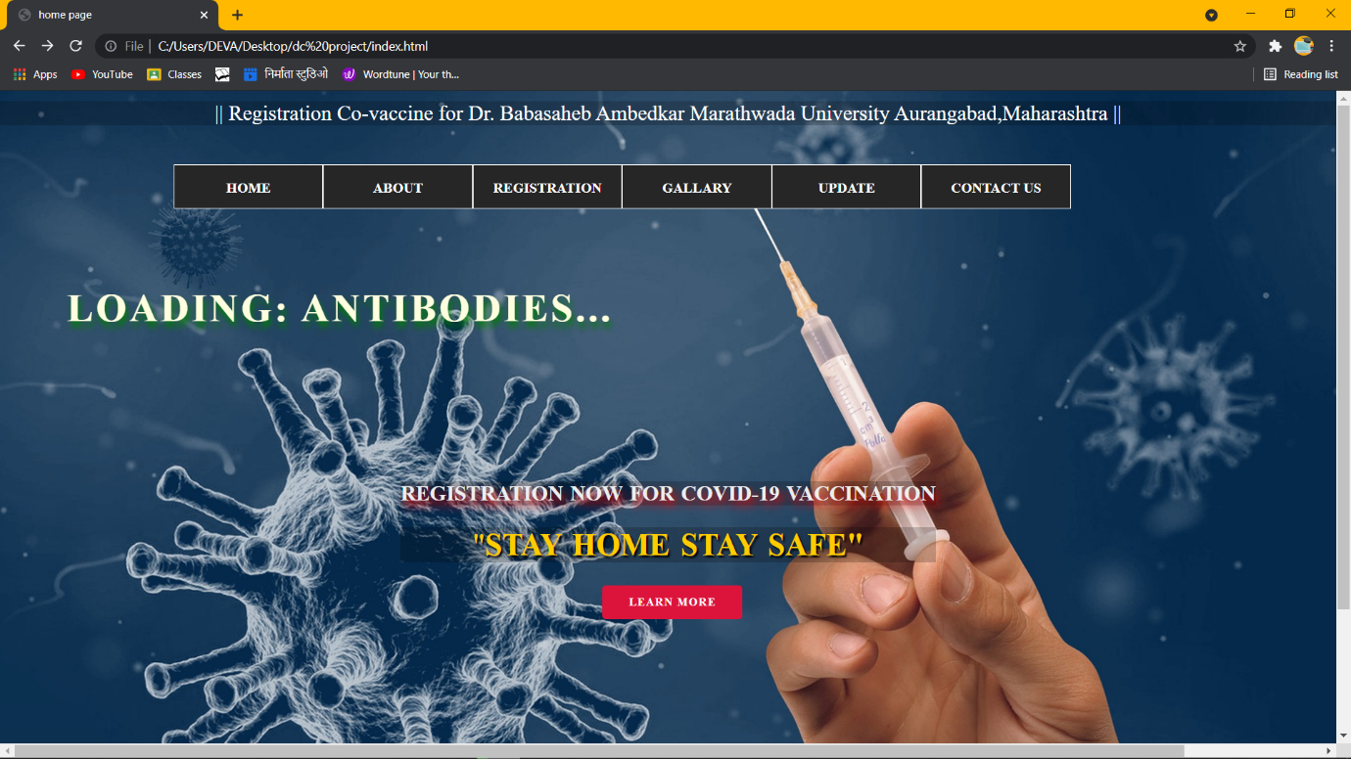

* **SCREENSHOT OF ABOUT US PAGE**

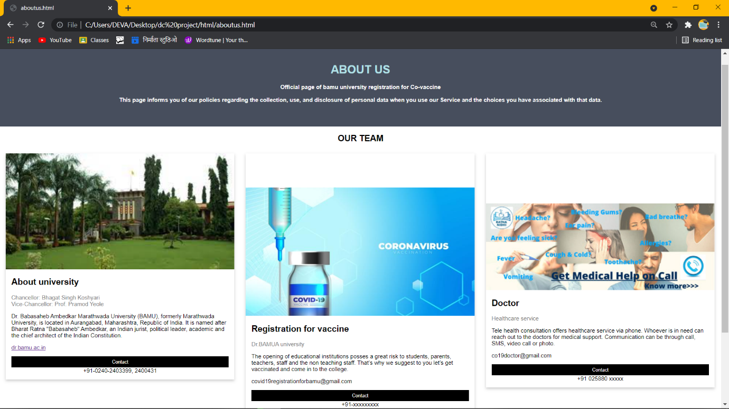

**SCREENSHOT OF ABOUT VACCINE PAGE**

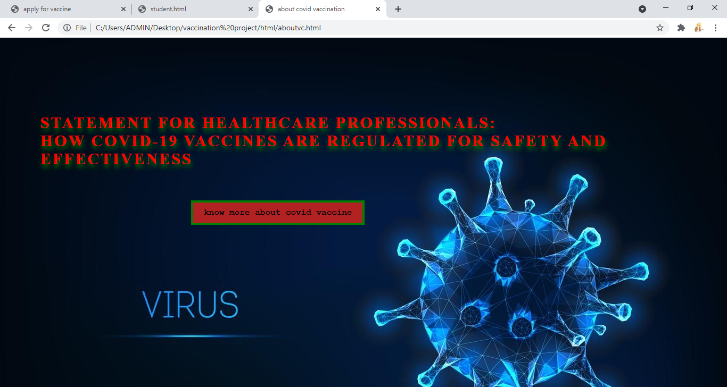

**SCREENSHOT OF REGISTRATION PAGE**

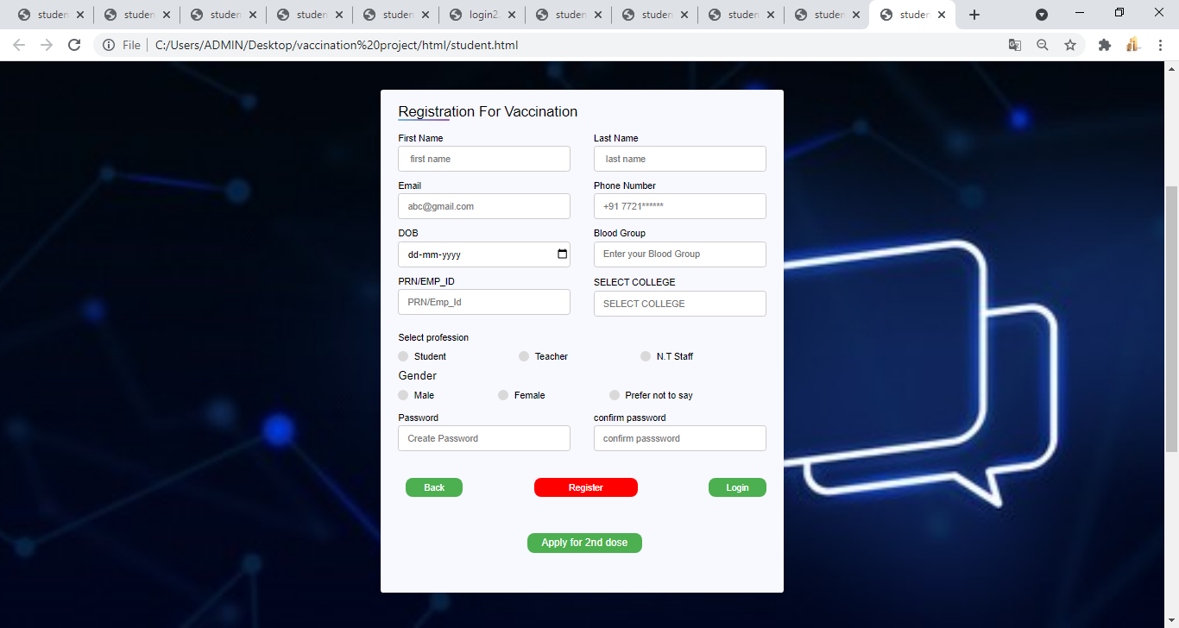

**SCREENSHOT OF 1ST DOSE LOGIN PAGE**

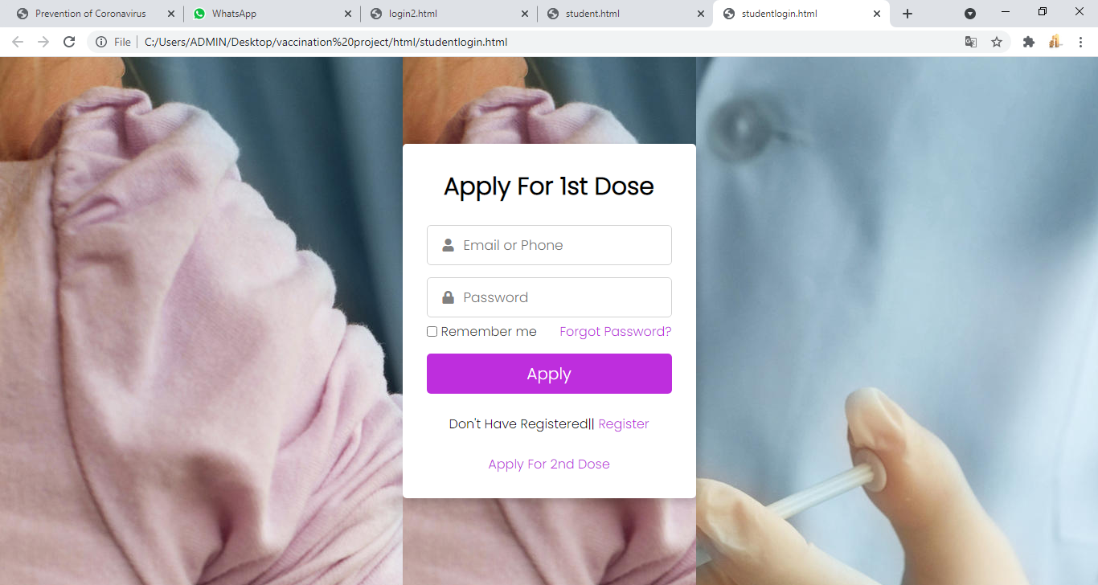

**SCREENSHOT OF THANK YOU FOR GETTING VACCINATION PAGE**

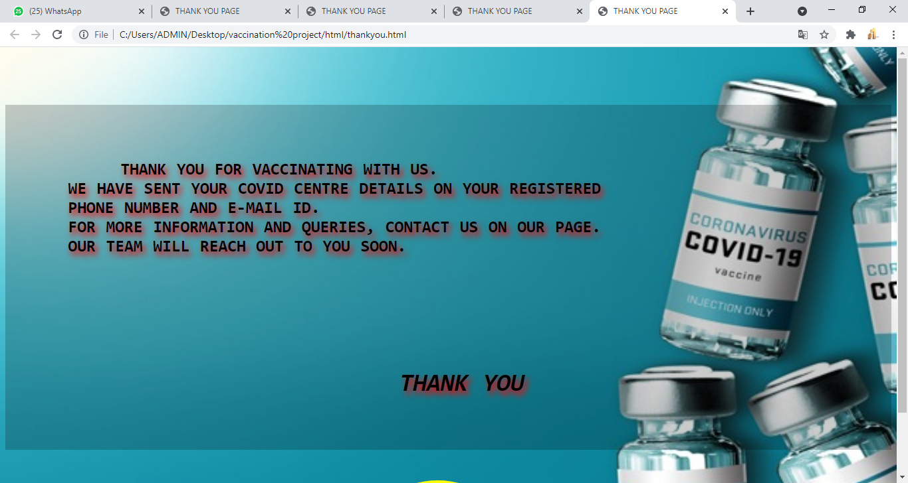

**SCREENSHOT OF APPLY FOR 2ND DOSE**

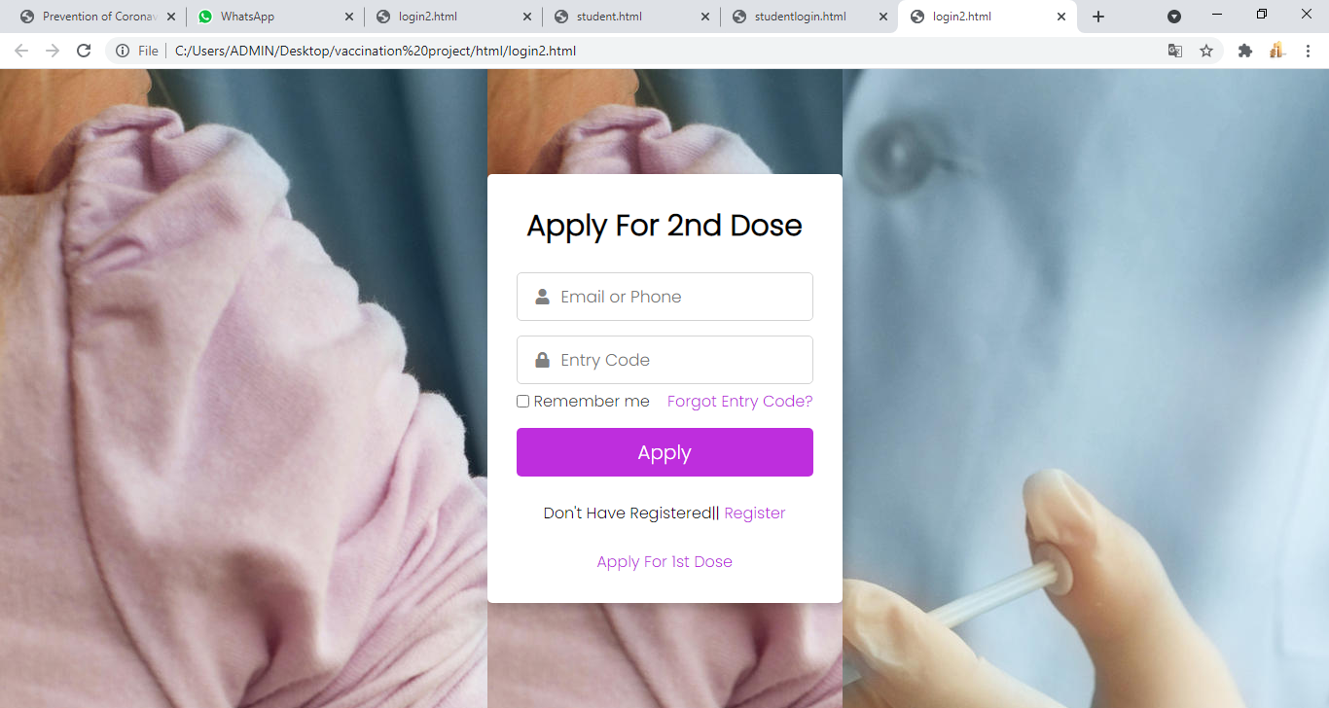

* **SCREENSHOT OF FORGOT PASSWORD PAGE**

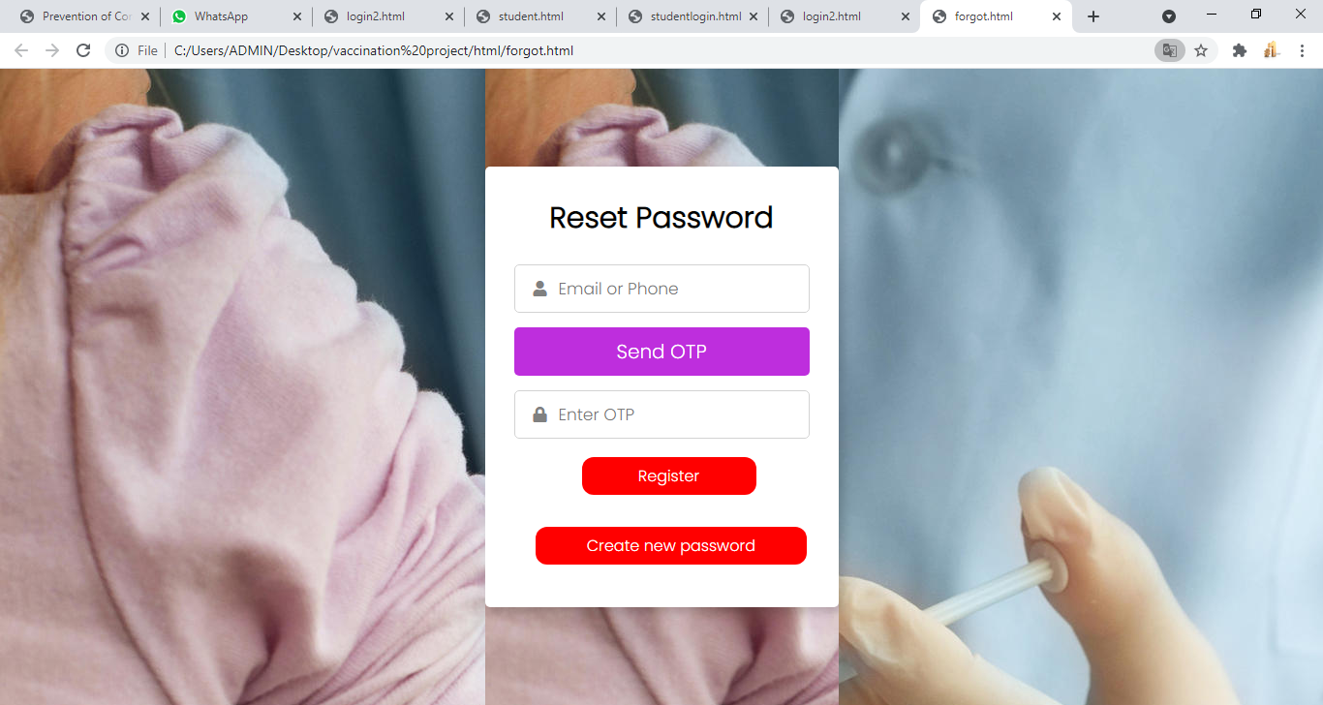

* **SCREENSHOT OF GALARY PAGE**

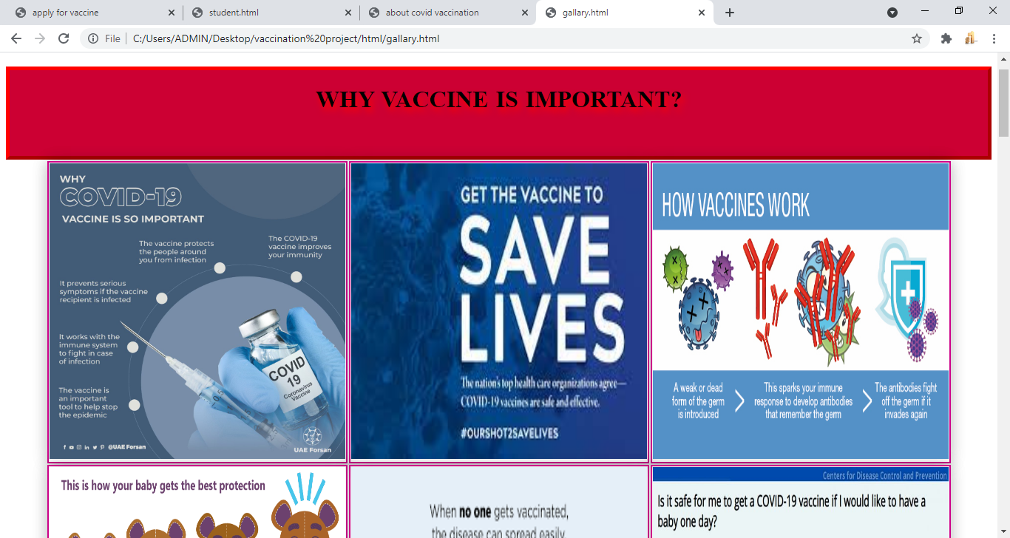

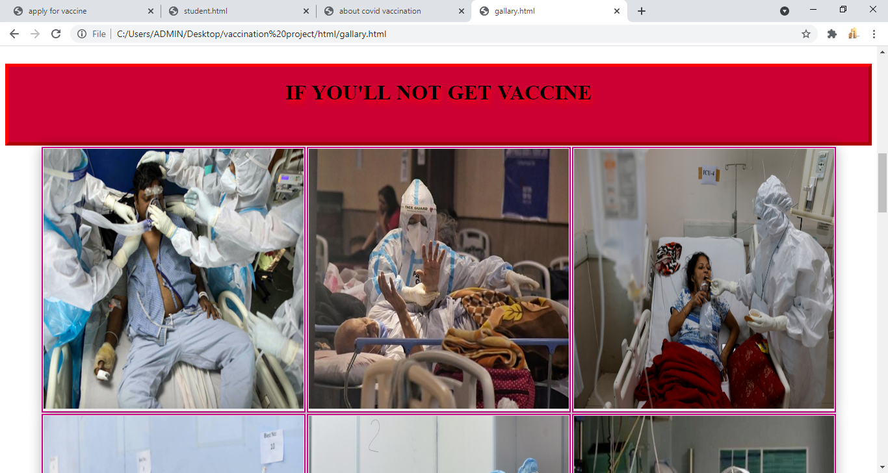

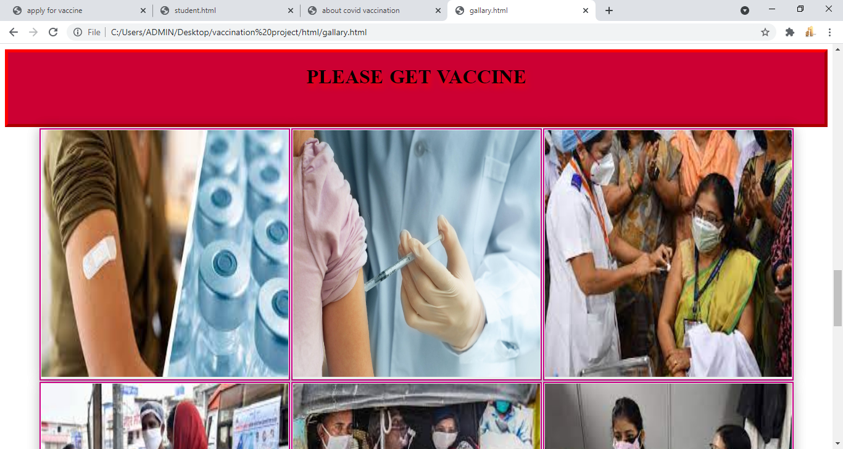

* **SCREENSHOT OF UPDATE PAGE**

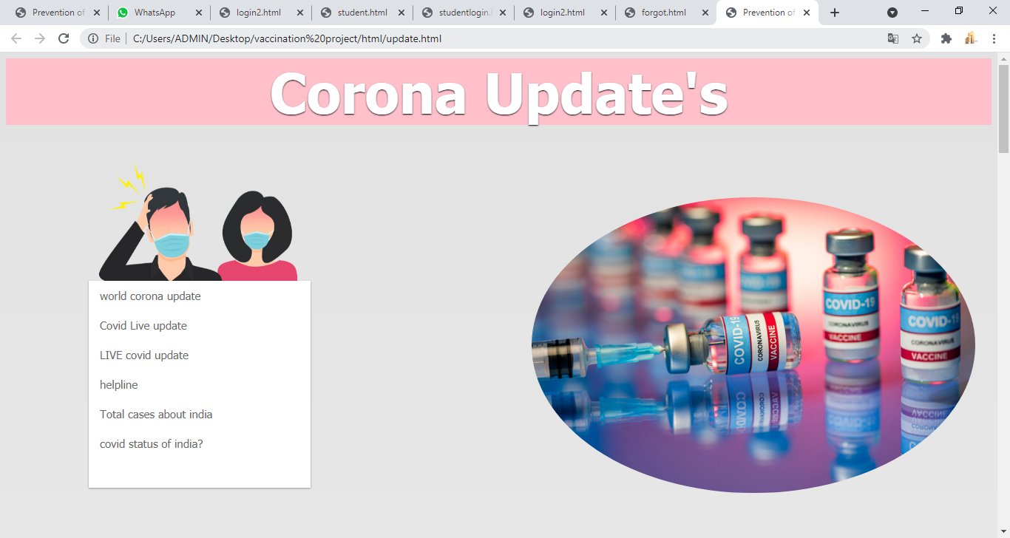

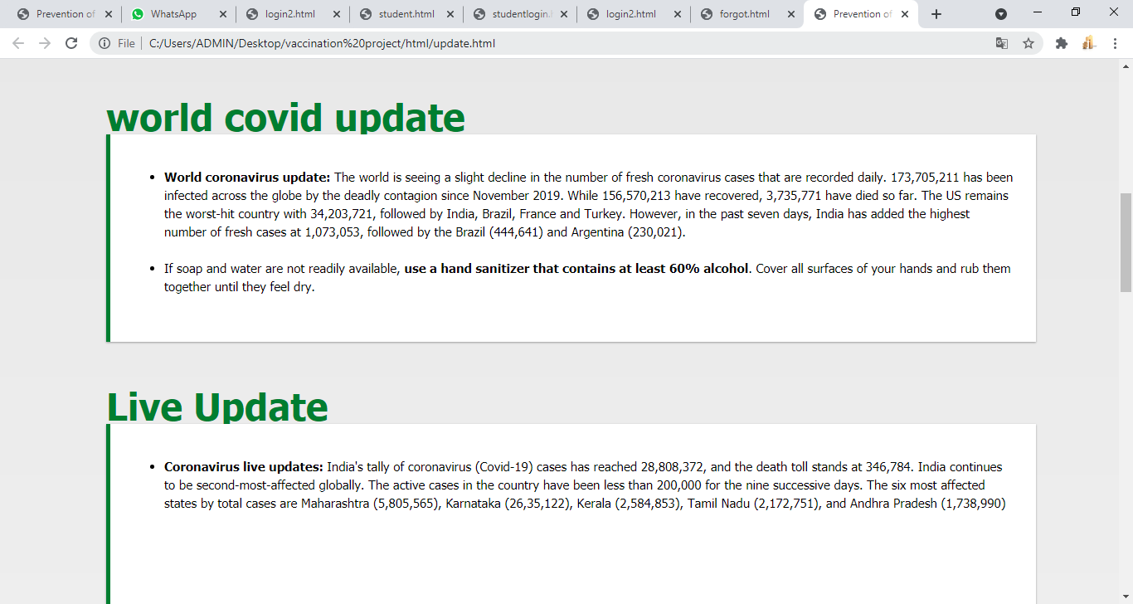

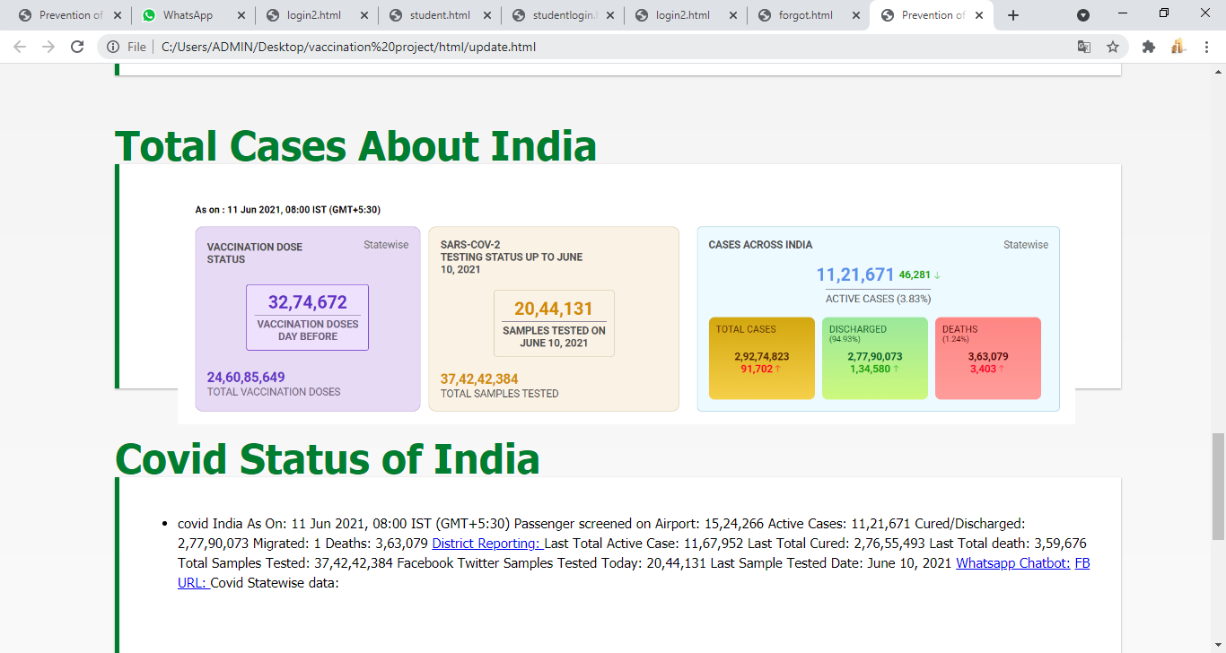

* **SCREENSHOT OF CONTACT US PAGE**

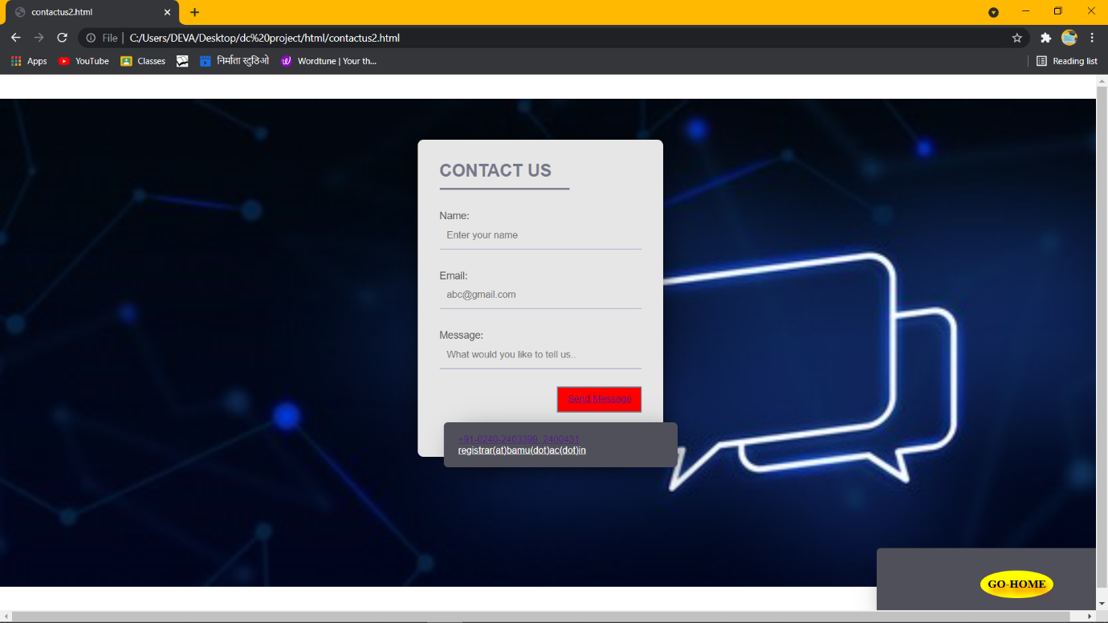

* **SCREENSHOT OF THANK FOR CONTACTING US PAGE**

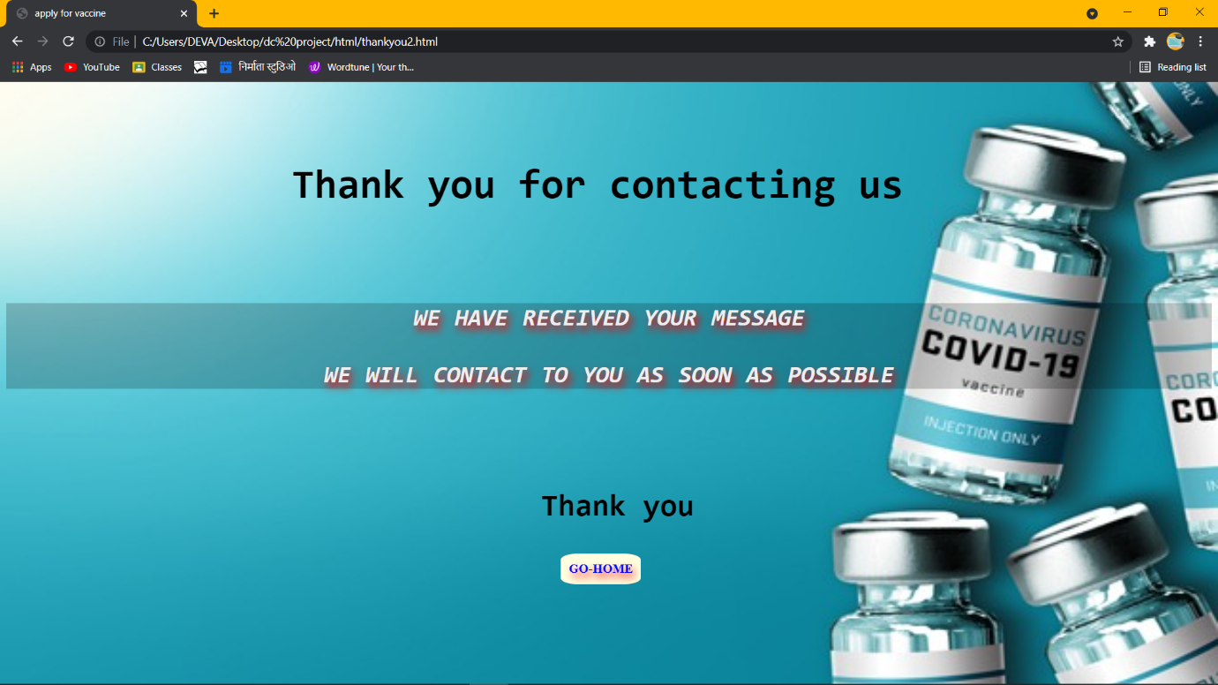

* **SCREENSHOT OF FREQUENTLY ASKED QUESTION (LEARN MORE) PAGE**

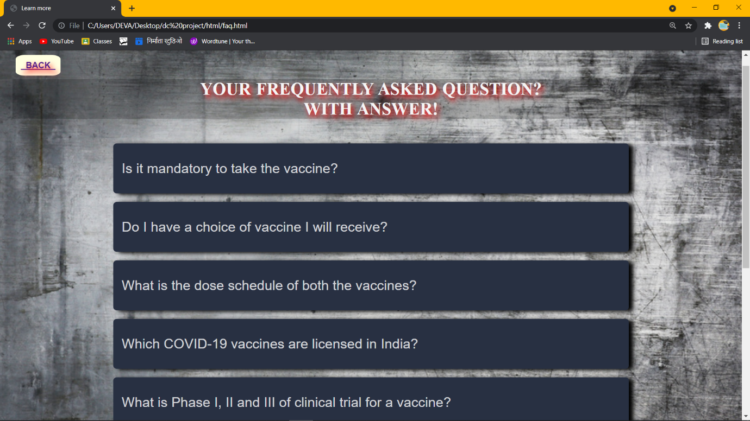

* **CONCLUSION**

This project is design for online covid vaccination, in this website everyone whose age is 18 and older people senior citizen again covid-19 so this website provide detail information how to resister yourself for to get vaccine.

Final decisions on the number of vaccines and the particular vaccines selected for accelerated development must Incorporates various non-quantifiable factors, as well as information provide by the ranking that were buried with the proposed system for calculating benefits and expenditure

* **REFERENCE**

[**https://www.github.com**](https://www.github.com)

[**https://www.stackoverflow.com**](https://www.stackoverflow.com)